COM-FSM Skills Expo 2015

By Gardner Edgar

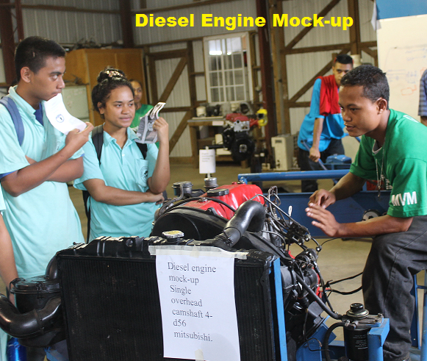Kolonia, Pohnpei – On April 23 and 24, the CTE (career & technical education) programs at COM-FSM Pohnpei campus successfully conducted its 8th annual Skills Expo, which included the degree programs in Hospitality & Tourism Management, Electronic Technology, Telecommunication, Building Technology, and certificate of achievement programs in Agriculture and Food Technology, Bookkeeping, Secretarial Science, Construction Electricity, Refrigeration & Air Conditioning, Carpentry, Cabinet & Furniture Making, and Motor Vehicle Mechanic. During the two-day event, each program showcased student learning outcomes through various program exhibits, which were set up, managed, and presented by students from each of the respective programs. Program exhibits ranged from hand crafted furniture made of local wood, wooden house & concrete room constructions, cooking demonstrations, dining services, residential & industrial wiring, and solar PV installation, home gardening & food processing, refrigerant recovery, recycle, & recharging, split type AC installation, gas & arc welding practices, refrigerant cycle, fiber optics installation, cell phone disassembly, integrated telecom system (fiber & microwave), LED TV parts and functions, photocopier disassembly, audio amplifier, bench Linux PC, automotive gas & diesel engines, and automotive electrical wiring system. Additionally, several programs (including the Electronic, Telecommunication, and Building Technology) provided presentations on career & future pathways in their respective fields of study.

Participants (visitors) of the two-day event included over 350 seniors from both public and private high schools and staff members of the FSM R&D Office. Of the college community, students, faculty, staff, the Vice President of Instructional Affairs and the Director of Academic Programs were also in attendance. Participants were provided a questionnaire survey for the event. 349 surveys are collected and the results are shown in the table below.

Questions | Strongly agree | Agree | Neutral | Disagree | Strongly Disagree
The setup of the exhibit area was well organized | 207 (59%) | 119 (34%) | 19 (5%) | 2 (1%) | 2 (1%)
The objectives for the Skills-Expo event were clearly communicated to the participants | 174 (50%) | 139 (40%) | 28 (8%) | 5 (1%) | 3 (1%)
I feel that these CTE programs are very useful to the development of the local workforce in the FSM. | 220 (63%) | 104 (30%) | 16 (5%) | 5 (1%) | 4 (1%)
Presentations at all showcases were easy to follow and understand | 183 (52%) | 123 (35%) | 37 (11%) | 4 (1%) | 2 (1%)
The materials used in the presentations helped provide a better picture of the training received in this program | 208 (60%) | 114 (33%) | 19 (5%) | 4 (1%) | 4 (1%)
The facility used for the presentations was adequate | 180 (52%) | 118 (34%) | 46 (13%) | 3 (1%) | 2 (1%)
I felt that the time allocated for each showcase/presentation was sufficient | 167 (49%) | 124 (36%) | 48 (14%) | 5 (1%) | 5 (1%)
I feel that the College of Micronesia – FSM should continue to provide training in the fields presented today | 226 (65%) | 100 (29%) | 13 (4%) | 7 (2%) | 3 (1%)
I understand and am now aware of the various types of CTE programs that are offered at COM-FSM Pohnpei campus | 203 (58%) | 116 (33%) | 22 (6%) | 6 (2%) | 2 (1%)
I feel that this event is an effective tool to market the graduates of the CTE programs | 222 (64%) | 100 (29%) | 22 (6%) | 3 (1%) | 2 (1%)

Based on the survey results, at least 90% of the participants agreed to the survey questions. Thus, the event was a success.

Special thanks to everyone who contributed to this year’s event including all staff, faculty, and most especially our valued students.

