II. Curriculum Committee: Authority, Purpose, and Structure

At COM-FSM, the Curriculum Committee (CC) functions in accordance with its college-approved governance document: the CC Terms of Reference. The current version of the Terms of Reference (TOR) appears below. The TOR are reviewed each August by CC and revised as necessary. The recommended TOR goes to Vice President of Instructional Affairs (VPIA) for review and recommendation to the Executive Committee by September 30th of each year. The Executive Committee must notify each committee of approved TOR by October 15th of each year. The approved TOR is posted to the college web site at wiki.comfsm.fm/Committee Terms of Reference.

CURRICULUM COMMITTEE (CC)
Terms of Reference

Authority

The Curriculum committee (CC) operates through the authority of and reports to the President. Recommendations from the committee are submitted through the Dean of Academic Programs (DAP) and/or Director of Career and Technical Education (DCTE) to the VPIA for approval by the President.

Purpose

The CC makes recommendations to the President through the DAP and /or DCTE and forwarded to the VPIA on matters relating to curriculum, instructional program review and assessment, instructional course review and assessment, academic policies and procedures.

Membership
(As amended 8/25/14; 9/7/15; 10/03/16; 8/21/17, 10/01/2018)

The members of the Curriculum Committee are selected at the beginning of each academic year and must include;

- Chuuk Campus Program Representative (2)
- Kosrae Campus Program Representative (1)
- FMI Program Representative (1)
- Yap Campus Program Representative (1)
- Achieving College Excellence Program Representative (1)
- AAS Technology & Trades Program Representative (1)
- CoA Technology & Trades Program Representative (1)
- Agriculture & Natural Resource Management and CoA Agriculture and Food Technology Program Representative (1)
- Business Administration/Computer Information Systems Representative (1)
- Education Program Representative (2)
- Micronesian Studies & Trial Counselor Program Representative (1)
- Public Health and Nursing Program Representative (1)
- Liberal Arts and Liberal Arts HCOP Program Representative (1)
- Marine Science Representative (1)
- Hospitality & Tourism Management and CoA Business Program Representative (1)
- General Education Program Representative (1)
- Learning Resource Center Representative (1)

Membership must be kept within 19 limit.

Responsibilities of committee members are to:
- Regularly prepare for and attend committee meetings;
- Actively participate in meetings;
- Share information on committee discussions, recommendations and decisions with the COM-FSM and gather input from their area of representation;
- Carry out assignments.

Organization

The CC will elect members to be Chair, Vice-chair, and Secretary prior to the beginning of an academic year.

The chairperson’s responsibilities are to:
- Prepare and distribute the agenda prior to each meeting;
- Preside over meetings;
- Ensure the terms of reference for the committee are met and matters brought before the committee are judiciously addressed;
- Ensure committee minutes, reports, and recommendations are completed and
appropriately disseminated in a timely manner;
- Forward recommendations through the DAP or DCTE to the VPIA for approval/action by the President within 5 working days;
- Communicate with the VPIA’s office for feedback on recommendations
- Distribute the official minutes to the VPIA, President, and COM-FSM community.
- Maintain a file on all minutes.

The responsibilities of the vice chairperson are to:
- Assist the chairperson with the above responsibilities.
- Preside over meetings in the absence of the chair.
- Upload or publish approved minutes (and documents) on the CC and COM-FSM Wiki page.

The responsibilities of the secretary are to:
- Review the meeting agenda with the chair and vice chair;
- Take and prepare accurate minutes;
- Record attendance of committee members;
- Distribute the minutes to the CC members for review 5 working days after the meeting.

The ex-officio member responsibilities:
- a non-voting member representing the VPIA’s office
- Will provide needed background information and clarification on academic policies or issues brought before the CC.

The VPIA should act as a “secretariat “position (secretariat = administrative support) to the CC.

Meetings and Voting

All CC meetings are held biweekly. The schedule is determined at the beginning of each academic term. The chairperson can call special meetings or upon consent of the majority of the members reschedule the regular meetings. Meetings can be held face-to-face or via teleconferences or other communication technologies. Twenty-five percent of membership constitutes a quorum for discussion purposes. A majority vote of all members is required to act on a motion. Electronic voting will be utilized when necessary. When a member does not vote, it is recorded as a “non-vote” and all other votes should be recorded as yes, no or abstain. When voting is required, the chair will work to ensure that all members vote so there is a minimum of non-votes. Results of electronic voting are to be documented in the next committee meeting minutes.

Responsibilities
(As amended 8/25/14; 9/7/15; 10/03/16)
The responsibilities of the CC are to:
- Review proposed Board policies and/or procedures assigned to the committee;
- Review and recommend for approval all new and modified instructional programs and course outlines – this includes regular college offerings and short-term training;
- Review recommendations made in instructional assessments, evaluations, and recommend strategies for improvement to instructional administrators.

Communications & Distribution of Information

Agenda items may be submitted to the chairperson by the COM-FSM community through the respective instructional coordinators and/or DAP. The chairperson compiles the agenda with the assistance of the vice chair and secretary and forwards it to committee members prior to meetings. All meetings are to have minutes that are to be distributed electronically within five working days of the meeting to members for their review. Members are to comment within the next five working days. The minutes, if approved are officially adopted at the next meeting. Electronic voting may be utilized when necessary. The chairperson distributes the official minutes to the VPIA, President, and COM-FSM. The chair maintains a file on all minutes. Following each meeting, the chairperson informs all concerned of decisions and forwards recommendations from the committee to the DAP, DCTE and VPIA. The chairperson also updates the members of the action taken on the committee’s recommendations. Committee members convey concerns and input on current issues from their respective areas to the committee. They also discuss the issues being addressed by the committee and share committee minutes with the community they represent.
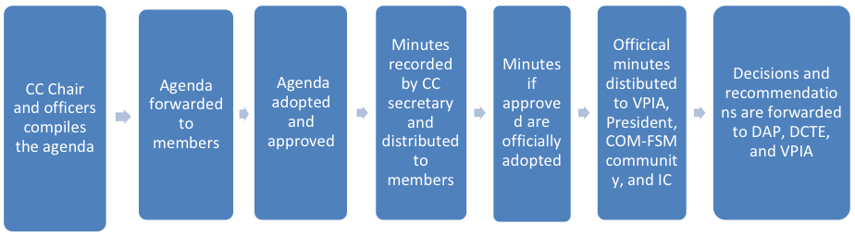

[Date Approved by CC: 26Oct2012; amended 25Aug2014; further amended and approved by CC 7 September 2015; further amended and approved by CC 17 October 2016; Revised 21 August 2017; Revised September 28, 2018]

