College of Micronesia – FSM
Minutes Reporting Form

Meeting Group: | IPR Lead Writers’ Workshop & Assessment Team

Date: | Time: | Location:
October 7, 2020 | 15:00 | Zoom

Summary of Recommendations with Suggested Timeline & Responsibilities:
- Share Word version of Program Modification request form, and template for manual saving of TracDat style data with ICs – VPIEQA. At same time as sharing minutes.
*** Added to the end of these minutes for convenience, noting that the manual form is less than perfect and may need modifying ***
- ICs – try using https://pdf2doc.com/ to convert PDF to word.
- Writers – ask another faculty member to check your Program Review and complete the checklist, before submitting to IC.
- Remind all of the resources in Curriculum Handbook

Members:
Titles/Representative | Name | Present | Absent | Remarks
DAP | Maria Dison
IC, National Campus | Joseph Felix Jr. |  |  | Late
IC, Chuuk Campus | Genevy Samuel
IC, CTEC | Taylor Elidok
IC Kosrae Campus | George Tilfas
IC Yap Campus | Thomas R. Foruw
Faculty member, NC | Peltin Olter-Pelep |  |  | Need to verify if still in A-Team.
Faculty member, NC | Angelina Tretnoff |  |  | Excused.
VPIEQA, Chair | Caroline Kocel
Registrar | Doman Daoas
Workshop Participants | Tara Tara, Rose Bueno, Paul Dacanay, Rudelyn Dacanay, Hiroki Noda, Salba Silbanuz, Romino Victor, Pelsihner E. Victor, Edper Castro, Francis Alex, Delihna Ehmes

Agenda:
1. Moment of Silence.
2. Reading of college mission statement
3. Roundtable - sections complete/incomplete and challenges faced.
4. Section 5.1 Findings.
5. Section 5.2 - SMART - specific, measurable, achievable, relevant, time-bound.
6. Who is responsible for using assessment results?
7. What next? (Complete. Submit to IC. IC does checklist and provides feedback. IC submits to A-team. Reader-teams. Endorse. VPIA. CC.)

Agenda/Major Topics of Discussion:

Recording of session
https://comfsm.zoom.us/rec/share/oH1km5MuUReTEbSbMjdkW0ged4ys_LExWGDoFCgxZDY7SJvtDE_apXrqZYwBbUw2.E48OY8IAQcj2tiG- Passcode:: WcjQL$a0

1. Moment of Silence.
2. Reading of college mission statement
3. Roundtable - sections complete/incomplete and challenges faced.

Participants were divided into three Zoom “breakout” rooms to work in small groups, sharing which sections of the Program Review they had been able to complete, or not – and what challenges they faced. Note – for most, this was their first experience using Zoom breakout rooms.

When participants came back as one group, ICs reported back from each of the breakout rooms.

Commonly, it was found that section 3.1 was challenging to complete, mainly because this section requires data from TracDat.

We recognize the many issues with TracDat that need to be resolved, especially regarding training and norms for inputting data.

Nevertheless, we ask this not to block continuing work on the program review:
- complete the sections that you can;
- if you get stuck move on;
- if data are not on TracDat, request missing data through IC’s;
- if you have data for some programs and not for all write in the available data and write in the analysis which data is available and which is missing.
- Make it clear what data you are analyzing and explain any discrepancy with a brief narrative.

IC George asked if it was ok to keep manual records of data in Kosrae. DAP confirmed she has a spreadsheet she has used for this purpose.

4. Section 5.1 Findings.
5. Section 5.2 - SMART - specific, measurable, achievable, relevant, time-bound.

A common recommendation of program reviews are changes that require a Progam Modification Request. People have varying levels of experience completing these:

Information on how to do a program modification can be found in the Curriculum Handbook,
- How to do modify a program = p17
- Template for Program Modification = Appendix J, p50.
- Course modification = Appendix E, p38

Try to break down the recommendation into smaller achievable steps with mini-milestones along the way.

6. Who is responsible for using assessment results?

Participants were asked to write their answers to this question in the chat – responses recognized that we are all responsible for using assessment results. Also, support from administration is required.

7. What next?

Complete Instructional Program Review.
Submit to IC - IC completes checklist and provides feedback.
When complete and of suitable quality, IC submits to A-team.
Reader-teams read the program review and may either provide feedback to the writers, or endorse.
Endorsed program reviews go to VPIA and onto Curriculum Committee.
Full process on program review are on p16 of the Program Assessment and Program Review Manual.

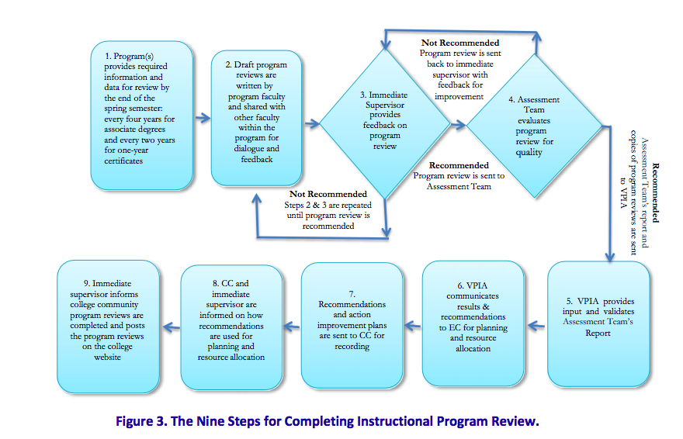

Comments/Upcoming Meeting Date & Time/Etc.:
The deadline for submitting IPRs was August 31st 2020. Since that time has passed, we ask writers to submit asap.

Handouts/Documents Referenced:
https://drive.google.com/drive/u/1/folders/1kAvZsJ0FuWc_O2BQtdIRG4Ci2QJK8uVJ

Curriculum Handbook

Program Assessment and Program Review Manual

Prepared by: | C. Kocel | Date Distributed: | 10/08/20

Appendix J. Degree Program Modification Request Form

Program Title: | Division: |  | Initiator:
New Program Mission:

New Program Description:

New Program Goals:

New Program Student Learning Outcomes:

New Program Requirements:

Justification for revising the program

Institutional Cost:

Decision: ____Approved ______Not Approved

Comment:

Instructional Coordinator |  | Date:
Chairperson, Curriculum Committee |  | Date:
An example of filled-out Program Modification Request Form appears on page 51.

Manual collection of assessment data following TracDat fields.

Term | CourseNo | CSLO | Activity | # students assessed | # students successful | # female successful | # male successful

Assessment plan for AY2020-2021:

Recommendation for improvement:

