Budget Assumptions for FY 2014
Four (4) scenarios

Scenario 1) Tuition increase with limited impact on student enrollment & credits
Scenario 2) Tuition & fees increase with limited impact on student enrollment & credits
Scenario 3) Tuition increase with projected impact on student enrollment & credits
Scenario 4) Tuition & fees increase with projected impact on student enrollment & credits

Scenario 1) Tuition increase with limited impact on student enrollment & credits

Assumptions

- Enrollment (FTE & Headcount) and Credits are estimated based on four year averages
- Tuition increase of $10/credit in FY 14 (115), FY 15 (125) & FY 16 (135)
  - No impact on student enrollment of tuition increase
- FSM will replace “all” ESG funding (for FY 2014 - $1,400,000 will be provided from the FSM general fund.
- No impact on student enrollment from changes in elementary and secondary enrollment
- No impact on student enrollment from out migration
- No changes will be expected based on broader changes in higher education (see for example: Ewell: “The New “Ecology” for Higher Education: Challenges to Community College Accreditation”)

Mitigation Activities (all scenarios)

- Accelerate recruitment efforts at the campuses and major/program levels
- Enhance courses offered and scheduling (evening classes, short term mastery courses)
- Enhance advising services
- Institute a first year college experience program (impact retention and graduation)
- Enhance tutoring services
- Enhance counseling services
- Writing center (national campus)
- Compare cost of regional and US costs of a college education as part of public information campaign – impact on refund and rationale for increases and cost of college education
- Enhanced information on changes in Financial Aid eligibility
- Secure advanced funding for summer pay (20%) – impact largest at National campus
- Institute distance learning for the college

Potential Fee Increases (as of 10/2/12 no decisions on new fees or fee increases)

- Facilities
- Cafeteria
- Dormitory
- Laboratory

Budget FY 2014 Revenue Projections
Scenario 1) Tuition increase with limited impact on student enrollment & credits
Revenue Source | Projection | Summary
Tuition @ $105/Credit | 7139895
Additional $10/Credit | 679990
Total Tuition |  | 7,819,885
Fees: Registration | 95,955
Fees: Health Fee | 95,955
Fees: Student Activity | 127,940
Fees: Laboratory | 21,080
Fees Dormitory | 120,124
Fees: Facilities
Fees: Other1 (see otherFees worksheet) | 74,265
Fees: Other2
Total Fees |  | 535,319
Indirect costs |  | 100,000
FSM ESG | 2,400,000
FSM General Fund | 1,400,000
Total FSM |  | 3,800,000
Other revenues1 (contracts)
Other revenues2
Total Other revenues |  | 0
Adjustment: Uncollectable (-) |  | -586,491
Adjustment: Employee tuition discount |  | -140,000
Total Operations Revenues |  | 11,528,713
Non Direct Operations
FMI: General Fund | 755,110
Fees: Technology | 639,700
Supplementary Education Grant (SEG) | 684,000
Auxiliary: Bookstore
Auxiliary: Cafeteria
Sponsored Programs TRIO
Sponsored Programs Gear Up
Sponsored Programs CRE
Sponsored Programs Other
Total non direct operations |  | 2,078,810
Total College |  | 13,607,523

Scenario 2) Tuition & fees increase with limited impact on student enrollment & credits

Assumptions

- Enrollment (FTE & Headcount) and Credits are estimated based on four year averages
- Tuition increase of $10/credit in FY 14 (115), FY 15 (125) & FY 16 (135)
  - No impact on student enrollment of tuition increase
- FSM will replace “all” ESG funding (for FY 2014 - $1,400,000 will be provided from the FSM general fund.
- No impact on student enrollment from changes in elementary and secondary enrollment
- No impact on student enrollment from out migration
- No changes will be expected based on broader changes in higher education (see Ewell: “The New “Ecology” for Higher Education: Challenges to Community College Accreditation”)
- Fees will be both added and increased (Potential – NOTE: as of 10/2/2012 no decisions have been made on new fees or increases in current fees – under discussion in administration or committees or both):
  - Facilities (discussion 10/2 $200/semester including summer)
  - Dormitory
  - Laboratory
  - Other

Mitigation Activities (all scenarios)

- Accelerate recruitment efforts at the campuses and major/program levels
- Enhance courses offered and scheduling (evening classes, short term mastery courses)
- Enhance advising services
- Institute a first year college experience program (impact retention and graduation)
- Enhance tutoring services
- Enhance counseling services
- Writing center (national campus)
- Compare cost of regional and US costs of a college education as part of public information campaign – impact on refund and rationale for increases and cost of college education
- Enhanced information on changes in Financial Aid eligibility
- Secure advanced funding for summer pay (20%) – impact largest at National campus
- Institute distance learning for the college

Potential Fee Increases (as of 10/2/12 no decisions on new fees or fee increases)

- Facilities (TCO at $200/semester including summer)
- Cafeteria
- Dormitory
- Laboratory

Budget FY 2014 Revenue Projections
Scenario 2) Tuition & fees increase with limited impact on student enrollment & credits
Revenue Source | Projection | Summary
Tuition @ $105/Credit | 7139895
Additional $10/Credit | 679990
Total Tuition |  | 7,819,885
Fees: Registration | 95,955
Fees: Health Fee | 95,955
Fees: Student Activity | 127,940
Fees: Laboratory | 21,080
Fees Dormitory | 120,124
Fees: TCO @ 200/semester | 1,279,200
Fees: Other1 (see otherFees worksheet) | 74,265
Fees: Other2
Total Fees |  | 1,814,519
Indirect costs |  | 100,000
FSM ESG | 2,400,000
FSM General Fund | 1,400,000
Total FSM |  | 3,800,000
Other revenues1 (contracts)
Other revenues2
Total Other revenues |  | 0
Adjustment: Uncollectable (-) |  | -586,491
Adjustment: Employee tuition discount |  | -140,000
Total Operations Revenues |  | 12,807,913
Non Direct Operations
FMI: General Fund | 755,110
Fees: Technology | 639,700
Supplementary Education Grant (SEG) | 684,000
Auxiliary: Bookstore
Auxiliary: Cafeteria
Sponsored Programs TRIO
Sponsored Programs Gear Up
Sponsored Programs CRE
Sponsored Programs Other
Total non direct operations |  | 2,078,810
Total College |  | 14,886,723

Scenario 3) Tuition increase with projected impact on student enrollment & credits

Assumptions

- Base Enrollment (FTE & Headcount) and Credits are estimated based on four year averages
- Projected total impact would be 9% of enrollment
- Tuition increase of $10/credit in FY 14 (115), FY 15 (125) & FY 16 (135)
  - Impact on student enrollment of tuition increase ( -4%) (-9%) overall impact low – cost of other IHEs (especially in US) greater than COM-FSM
  - Dorm students impact ( Students would be considering the impact of tuition increases over 3 years) (-20%) consideration for tuition alone
- FSM will replace “all” ESG funding (for FY 2014 - $1,400,000 will be provided from the FSM general fund. This is based on comments for key national leaders regarding support for the college.
- Impact on student enrollment from changes in elementary and secondary enrollment ( ) May not see too much 2014 but greater in future years (impact included in tuition increase)
- Impact on student enrollment from out migration ( ) May not see too much 2014 but greater in future years (impact included in tuition increase)
- Changes will be expected based on broader changes in higher education (see Ewell: “The New “Ecology” for Higher Education: Challenges to Community College Accreditation”) ( -1%) 1) From VPCRE FSM students enrolled at PCC in agriculture 30 of 40 from Chuuk and other 10 from Yap (all PCC agriculture students are from FSM) – to be confirmed by VPCRE (distance learning) UOG masters, USDA masters (BA in PCC) could expand enrollment
- Fees will not be added and increased (Potential – NOTE: as of 10/2/2012 no decisions have been made on new fees or increases in current fees – under discussion in administration or committees or both):
  - Facilities (discussion 10/2 $200/semester including summer)
  - Dormitory
  - Laboratory
  - Other
- No changes in structure of the college

Discussion

A focus of discussion on impact of tuition and fees increases on enrollment was around summer semester and students in fall and spring semesters who are taking only one or two courses. As an example, if a student takes two courses in summer: Tuition $690, covered by SEG 50% (expect for dorm students) $345; Fees Registration/health/student fees $50, Technology $100; TCO $200; books @ $100/course; Out of pocket expense to the student would be $795. Even for one course – out of pocket cost would be $$622.50. Dorm students will likely be the most affected as scholarship funds have declined and Pell Grant awards remain the same.

Mitigation Activities (all scenarios)

- Accelerate recruitment efforts at the campuses and major/program levels
- Enhance courses offered and scheduling (evening classes, short term mastery courses)
- Enhance advising services
- Institute a first year college experience program (impact retention and graduation)
- Enhance tutoring services
- Enhance counseling services
- Writing center (national campus)
- Compare cost of regional and US costs of a college education as part of public information campaign – impact on refund and rationale for increases and cost of college education
- Enhanced information on changes in Financial Aid eligibility
- Secure advanced funding for summer pay (20%) – impact largest at National campus
- Institute distance learning for the college

Potential Fee Increases (as of 10/2/12 no decisions on new fees or fee increases)

- Facilities (TCO at $200/semester including summer)
- Cafeteria
- Dormitory
- Laboratory

Budget FY 2014 Revenue Projections
Scenario 3) Tuition increase with projected impact on student enrollment & credits
Revenue Source | Projection | Summary
Tuition @ $105/Credit | 6854299
Additional $10/Credit | 652790
Total Tuition |  | 7,507,089
Fees: Registration | 92,117
Fees: Health Fee | 92,117
Fees: Student Activity | 122,822
Fees: Laboratory | 21,080
Fees Dormitory | 100,000
Fees: Facilities
Fees: Other1 (see otherFees worksheet) | 74,265
Fees: Other2
Total Fees |  | 502,401
Indirect costs |  | 100,000
FSM ESG | 2,400,000
FSM General Fund | 1,400,000
Total FSM |  | 3,800,000
Other revenues1 (contracts)
Other revenues2
Total Other revenues |  | 0
Adjustment: Uncollectable (-) |  | -563,032
Adjustment: Employee tuition discount |  | -140,000
Total Operations Revenues |  | 11,206,458
Non Direct Operations
FMI: General Fund | 755,110
Fees: Technology | 614,112
Supplementary Education Grant (SEG) | 684,000
Auxiliary: Bookstore
Auxiliary: Cafeteria
Sponsored Programs TRIO
Sponsored Programs Gear Up
Sponsored Programs CRE
Sponsored Programs Other
Total non direct operations |  | 2,053,222
Total College |  | 13,259,680

Scenario 4) Tuition & fees increase with projected impact on student enrollment & credits

Assumptions

- Base Enrollment (FTE & Headcount) and Credits are estimated based on four year averages
- Tuition increase of $10/credit in FY 14 (115), FY 15 (125) & FY 16 (135)
  - Impact on student enrollment of tuition increase (-9%) overall impact low – cost of other IHEs (especially in US) greater than COM-FSM
  - Dorm students impact ( Students would be considering the impact of tuition increases over 3 years) (-20%) consideration for tuition alone
- FSM will replace “all” ESG funding (for FY 2014 - $1,400,000 will be provided from the FSM general fund. This is based on comments for key national leaders regarding support for the college.
- Impact on student enrollment from changes in elementary and secondary enrollment ( ) May not see too much 2014 but greater in future years (impact included in tuition increase)
- Impact on student enrollment from out migration ( ) May not see too much 2014 but greater in future years (impact included in tuition increase)
- Changes will be expected based on broader changes in higher education (see Ewell: “The New “Ecology” for Higher Education: Challenges to Community College Accreditation”) ( -1%) 1) From VPCRE FSM students enrolled at PCC in agriculture 30 of 40 from Chuuk and other 10 from Yap (all PCC agriculture students are from FSM) – to be confirmed by VPCRE (distance learning) UOG masters, USDA masters (BA in PCC) could expand enrollment
- Fees will not be added and increased (Potential – NOTE: as of 10/2/2012 no decisions have been made on new fees or increases in current fees – under discussion in administration or committees or both):
  - Facilities (discussion 10/2 $200/semester including summer)
  - Dormitory
  - Laboratory
  - Other
- No changes in structure of the college

Discussion

A focus of discussion on impact of tuition and fees increases on enrollment was around summer semester and students in fall and spring semesters who are taking only one or two courses. As an example, if a student takes two courses in summer: Tuition $690, covered by SEG 50% (expect for dorm students) $345; Fees Registration/health/student fees $50, Technology $100; TCO $200; Out of pocket expense to the student would be $695. Even for one course – out of pocket cost would be $$522.50. Dorm students will likely be the most affected as scholarship funds have declined and Pell Grant awards remain the same.

Mitigation Activities (all scenarios)

- Accelerate recruitment efforts at the campuses and major/program levels
- Enhance courses offered and scheduling (evening classes, short term mastery courses)
- Enhance advising services
- Institute a first year college experience program (impact retention and graduation)
- Enhance tutoring services
- Enhance counseling services
- Writing center (national campus)
- Compare cost of regional and US costs of a college education as part of public information campaign – impact on refund and rationale for increases and cost of college education
- Enhanced information on changes in Financial Aid eligibility
- Secure advanced funding for summer pay (20%) – impact largest at National campus
- Institute distance learning for the college

Potential Fee Increases (as of 10/2/12 no decisions on new fees or fee increases)

- Facilities (TCO at $200/semester including summer)
- Cafeteria
- Dormitory
- Laboratory

Budget FY 2014 Revenue Projections
Scenario 4) Tuition & fees increase with projected impact on student enrollment & credits
Revenue Source | Projection | Summary
Tuition @ $105/Credit | 6497304
Additional $10/Credit | 618791
Total Tuition |  | 7,116,095
Fees: Registration | 87,319
Fees: Health Fee | 87,319
Fees: Student Activity | 116,425
Fees: Laboratory | 21,080
Fees Dormitory | 100,000
Fees: TCO @ 200/semester | 1,164,254
Fees: Other1 (see otherFees worksheet) | 76,562
Fees: Other2
Total Fees |  | 1,652,959
Indirect costs |  | 100,000
FSM ESG | 2,400,000
FSM General Fund | 1,400,000
Total FSM |  | 3,800,000
Other revenues1 (contracts)
Other revenues2
Total Other revenues |  | 0
Adjustment: Uncollectable (-) |  | -533,707
Adjustment: Employee tuition discount |  | -140,000
Total Operations Revenues |  | 11,995,347
Non Direct Operations
FMI: General Fund | 755,110
Fees: Technology | 696,700
Supplementary Education Grant (SEG) | 684,000
Auxiliary: Bookstore
Auxiliary: Cafeteria
Sponsored Programs TRIO
Sponsored Programs Gear Up
Sponsored Programs CRE
Sponsored Programs Other
Total non direct operations |  | 2,135,810
Total College |  | 14,131,157

Budget 2014 Data & Graphs for Enrollment & Credits Projections
Fall enrollment
Term | Chuuk | Kosrae | National | Pohnpei | Yap | Total
Fall 2009 | 580 | 233 | 1005 | 712 | 228 | 2758
Fall 2010 | 479 | 218 | 1051 | 742 | 209 | 2699
Fall 2011 | 493 | 261 | 1088 | 845 | 228 | 2915
Fall 2012 | 409 | 268 | 1069 | 771 | 227 | 2744
Spring enrollment
Term | Chuuk | Kosrae | National | Pohnpei | Yap | Total
Spring 2009 | 420 | 224 | 809 | 545 | 201 | 2199
Spring 2010 | 565 | 202 | 918 | 586 | 209 | 2480
Spring 2011 | 433 | 219 | 984 | 561 | 195 | 2392
Spring 2012 | 428 | 244 | 958 | 693 | 221 | 2544
Summer enrollment
Term | Chuuk | Kosrae | National | Pohnpei | Yap | Total
Summer 2009 | 363 | 139 | 665 | 423 | 182 | 1772
Summer 2010 | 349 | 160 | 867 | 384 | 221 | 1981
Summer 2011 | 334 | 235 | 905 | 429 | 206 | 2109
summer 2012 | 199 | 144 | 557 | 267 | 108 | 1275
Percent Spring Term to Fall Enrollment
Term | Chuuk | Kosrae | National | Pohnpei | Yap | Total
Fall09Sp10 | 97.4% | 86.7% | 91.3% | 82.3% | 91.7% | 89.9%
Fall10Sp11 | 90.4% | 100.5% | 93.6% | 75.6% | 93.3% | 88.6%
Fall11Sp12 | 86.8% | 93.5% | 88.1% | 82.0% | 96.9% | 87.3%

Fall credits
Term | Chuuk | Kosrae | National | Pohnpei | Yap | Total
Fall 2009 | 6596 | 2260.5 | 12087 | 8031 | 2570 | 31544.5
Fall 2010 | 5848.0 | 2483.5 | 12958.0 | 8647.0 | 2542.5 | 32479.0
Fall 2011 | 5953.0 | 2679.5 | 13576.0 | 9243.5 | 2693.0 | 34145.0
Fall 2012 | 5058 | 2575.5 | 13109 | 8053.5 | 2431.5 | 31227.5
Spring credits
Term | Chuuk | Kosrae | National | Pohnpei | Yap | Total
Spring 2009 | 4836.5 | 2254 | 10254 | 6534.5 | 2121 | 26000
Spring 2010 | 6528 | 2056 | 11638 | 6945 | 2296 | 29463
Spring 2011 | 5281.0 | 2223.0 | 12308.5 | 6682.5 | 2247.0 | 28742.0
Spring 2012 | 5097 | 2350 | 12070 | 7840 | 2419 | 29776
Summer credits
Term | Chuuk | Kosrae | National | Pohnpei | Yap | Total
Summer 2009 | 2080 | 620 | 3426 | 2002 | 1059 | 9187
Summer 2010 | 2129 | 777 | 4784 | 2004 | 1273 | 10967
Summer 2011 | 1991 | 1221 | 5251 | 2280.5 | 1122 | 11865.5
summer 2012 | 1158 | 738 | 3032 | 1386 | 534 | 6848
Percent Spring Term to Fall (Credits)
Term | Chuuk | Kosrae | National | Pohnpei | Yap | Total
Fall09Sp10 | 99.0% | 91.0% | 96.3% | 86.5% | 89.3% | 93.4%
Fall10Sp11 | 90.3% | 89.5% | 95.0% | 77.3% | 88.4% | 88.5%
Fall11Sp12 | 85.6% | 87.7% | 88.9% | 84.8% | 89.8% | 87.2%

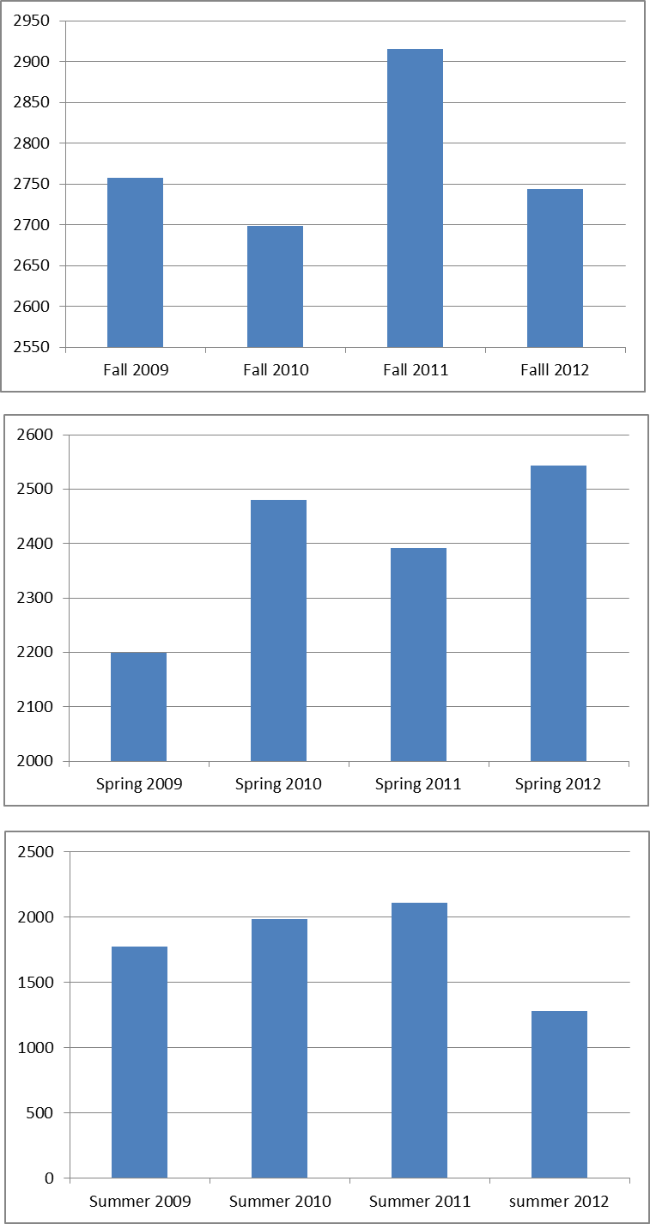  Figure 1 Enrollment Totals | 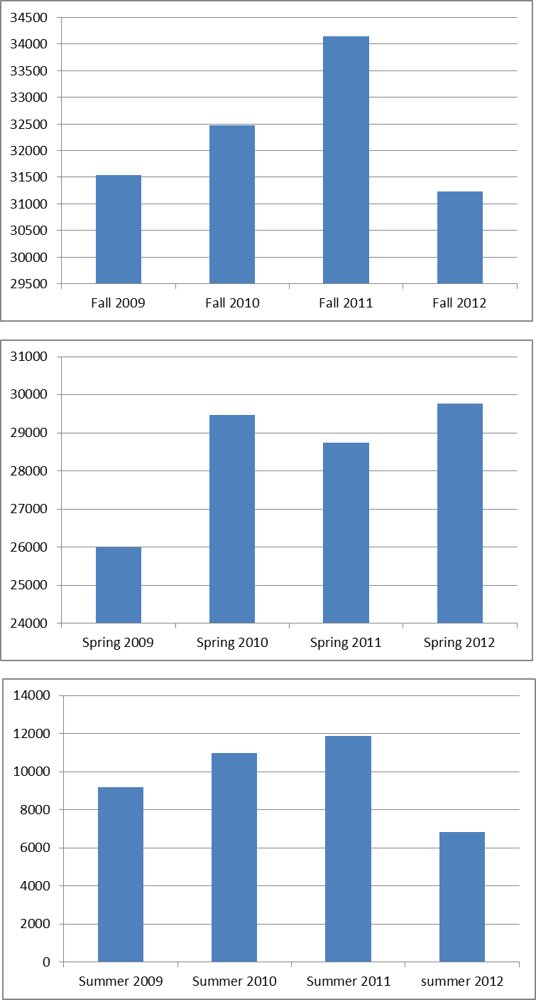  Figure 2 Credits Totals

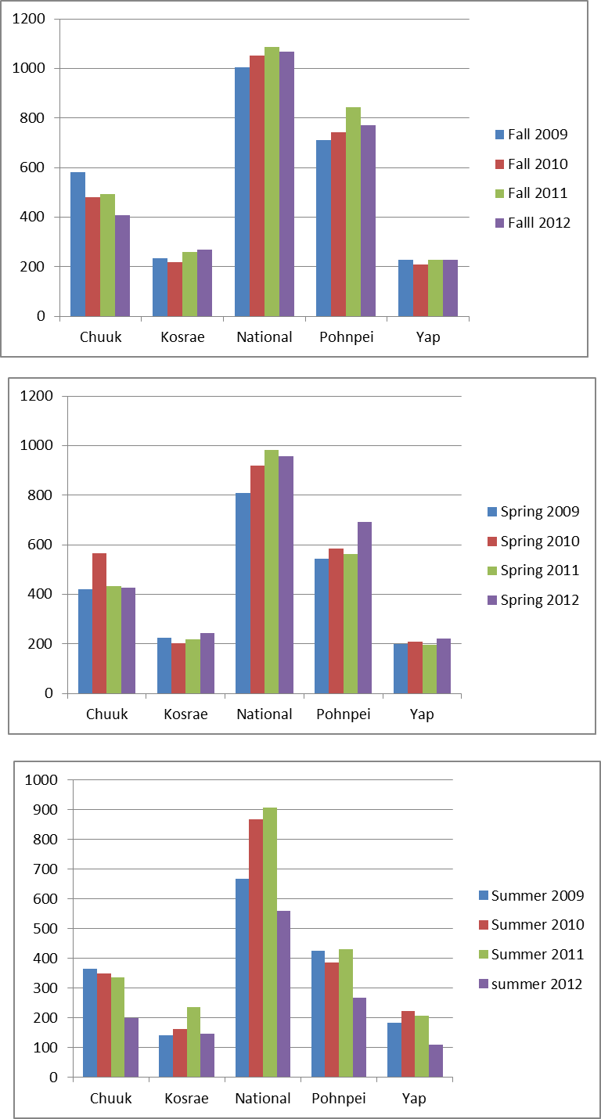  Figure 3 Enrollment by Campus | 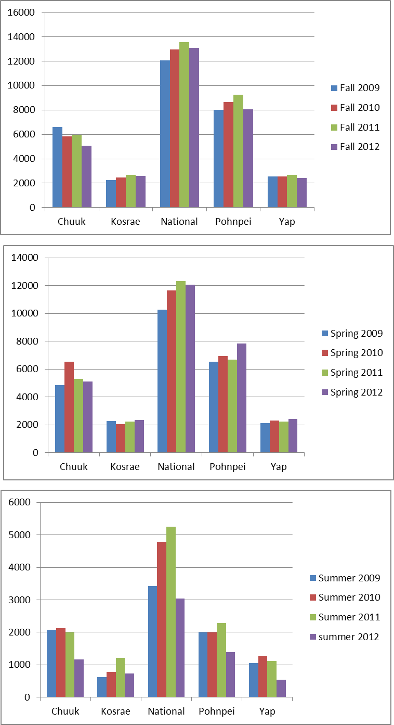  Figure 4 Credits by Campus

Summer 2007, 2008, 2009 & 2012
Type | Term | Chuuk | Kosrae | National | Pohnpei | Yap | Total
enrollment | summer 2007 | 206 | 108 | 455 | 172 | 174 | 1115
enrollment | summer 2008 | 166 | 103 | 542 | 285 | 174 | 1270
enrollment | summer 2009 | 363 | 139 | 665 | 423 | 182 | 1772
enrollment | summer 2012 | 199 | 144 | 557 | 267 | 108 | 1275
credits | summer 2007 | 1117 | 483.5 | 2550 | 760 | 997 | 5907.5
credits | summer 2008 | 892 | 389 | 3117 | 1322 | 945 | 6665
credits | summer 2009 | 2080 | 620 | 3426 | 2002 | 1059 | 9187
credits | summer 2012 | 1158 | 738 | 3032 | 1386 | 534 | 6848

> # Budget 2014 enrollment and credits data by describe.by for revenue projections
>
>
> describe.by(enroll, enroll$Term)
group: Fall
var n mean sd median trimmed mad min max range skew kurtosis se
Term* 1 4 1.00 0.00 1.0 1.00 0.00 1 1 0 NaN NaN 0.00
Chuuk 2 4 490.25 70.22 486.0 490.25 62.27 409 580 171 0.13 -1.88 35.11
Kosrae 3 4 245.00 23.51 247.0 245.00 25.95 218 268 50 -0.10 -2.27 11.75
National 4 4 1053.25 35.54 1060.0 1053.25 27.43 1005 1088 83 -0.37 -1.91 17.77
Pohnpei 5 4 767.50 57.01 756.5 767.50 43.74 712 845 133 0.38 -1.91 28.50
Yap 6 4 223.00 9.35 227.5 223.00 0.74 209 228 19 -0.74 -1.69 4.67
Total 7 4 2779.00 94.10 2751.0 2779.00 43.74 2699 2915 216 0.59 -1.77 47.05
-----------------------------------------------------------------------------------------------
group: Spring
var n mean sd median trimmed mad min max range skew kurtosis se
Term* 1 4 2.00 0.00 2.0 2.00 0.00 2 2 0 NaN NaN 0.00
Chuuk 2 4 461.50 69.21 430.5 461.50 9.64 420 565 145 0.74 -1.70 34.60
Kosrae 3 4 222.25 17.29 221.5 222.25 16.31 202 244 42 0.09 -1.90 8.64
National 4 4 917.25 77.10 938.0 917.25 48.93 809 984 175 -0.49 -1.87 38.55
Pohnpei 5 4 596.25 66.67 573.5 596.25 30.39 545 693 148 0.61 -1.78 33.34
Yap 6 4 206.50 11.24 205.0 206.50 10.38 195 221 26 0.24 -2.02 5.62
Total 7 4 2403.75 150.05 2436.0 2403.75 112.68 2199 2544 345 -0.40 -1.93 75.02
-----------------------------------------------------------------------------------------------
group: Summer
var n mean sd median trimmed mad min max range skew kurtosis se
Term* 1 4 3.00 0.00 3.0 3.00 0.00 3 3 0 NaN NaN 0.00
Chuuk 2 4 311.25 75.76 341.5 311.25 21.50 199 363 164 -0.70 -1.72 37.88
Kosrae 3 4 169.50 44.58 152.0 169.50 15.57 139 235 96 0.66 -1.75 22.29
National 4 4 748.50 165.51 766.0 748.50 177.91 557 905 348 -0.12 -2.27 82.75
Pohnpei 5 4 375.75 75.19 403.5 375.75 33.36 267 429 162 -0.61 -1.80 37.60
Yap 6 4 179.25 50.14 194.0 179.25 28.91 108 221 113 -0.53 -1.84 25.07
Total 7 4 1784.25 366.81 1876.5 1784.25 249.82 1275 2109 834 -0.46 -1.90 183.41
>
> describe.by(credits, credits$Term)
group: Fall
var n mean sd median trimmed mad min max range skew kurtosis se
Term* 1 4 1.00 0.00 1.00 1.00 0.00 1.0 1.0 0.0 NaN NaN 0.00
Chuuk 2 4 5863.75 630.78 5900.50 5863.75 554.49 5058.0 6596.0 1538.0 -0.13 -1.88 315.39
Kosrae 3 4 2499.75 178.47 2529.50 2499.75 145.29 2260.5 2679.5 419.0 -0.33 -1.93 89.23
National 4 4 12932.50 622.03 13033.50 12932.50 458.12 12087.0 13576.0 1489.0 -0.35 -1.86 311.02
Pohnpei 5 4 8493.75 575.49 8350.25 8493.75 456.64 8031.0 9243.5 1212.5 0.32 -2.09 287.75
Yap 6 4 2559.25 107.40 2556.25 2559.25 102.67 2431.5 2693.0 261.5 0.06 -1.90 53.70
Total 7 4 32349.00 1309.90 32011.75 32349.00 927.74 31227.5 34145.0 2917.5 0.43 -1.95 654.95
-----------------------------------------------------------------------------------------------
group: Spring
var n mean sd median trimmed mad min max range skew kurtosis se
Term* 1 4 2.00 0.00 2.00 2.00 0.00 2.0 2.0 0.0 NaN NaN 0.00
Chuuk 2 4 5435.62 750.74 5189.00 5435.62 329.51 4836.5 6528.0 1691.5 0.62 -1.77 375.37
Kosrae 3 4 2220.75 122.42 2238.50 2220.75 94.15 2056.0 2350.0 294.0 -0.31 -1.87 61.21
National 4 4 11567.62 918.67 11854.00 11567.62 497.04 10254.0 12308.5 2054.5 -0.56 -1.83 459.33
Pohnpei 5 4 7000.50 584.84 6813.75 7000.50 304.30 6534.5 7840.0 1305.5 0.57 -1.82 292.42
Yap 6 4 2270.75 123.29 2271.50 2270.75 127.50 2121.0 2419.0 298.0 -0.01 -1.93 61.65
Total 7 4 28495.25 1718.92 29102.50 28495.25 766.50 26000.0 29776.0 3776.0 -0.62 -1.79 859.46
-----------------------------------------------------------------------------------------------
group: Summer
var n mean sd median trimmed mad min max range skew kurtosis se
Term* 1 4 3.00 0.00 3.0 3.00 0.00 3 3.0 0.0 NaN NaN 0.00
Chuuk 2 4 1839.50 457.91 2035.5 1839.50 102.30 1158 2129.0 971.0 -0.72 -1.71 228.96
Kosrae 3 4 839.00 263.27 757.5 839.00 116.38 620 1221.0 601.0 0.60 -1.77 131.63
National 4 4 4123.25 1062.29 4105.0 4123.25 1298.76 3032 5251.0 2219.0 0.02 -2.32 531.15
Pohnpei 5 4 1918.12 378.10 2003.0 1918.12 206.45 1386 2280.5 894.5 -0.47 -1.81 189.05
Yap 6 4 997.00 321.46 1090.5 997.00 158.64 534 1273.0 739.0 -0.57 -1.78 160.73
Total 7 4 9716.88 2212.89 10077.0 9716.88 1985.57 6848 11865.5 5017.5 -0.27 -2.05 1106.44
>
>
>
Summer data 2007, 2008, 2009, 2012 (2010 & 2011 skewed due to Year Round Pell)

group: credits
var n mean sd median trimmed mad min max range skew kurtosis se
type* 1 4 1.00 0.00 1.00 1.00 0.00 1.0 1 0.0 NaN NaN 0.00
Chuuk 2 4 1311.75 525.35 1137.50 1311.75 197.19 892.0 2080 1188.0 0.64 -1.75 262.67
Kosrae 3 4 557.62 153.14 551.75 557.62 171.24 389.0 738 349.0 0.06 -2.13 76.57
National 4 4 3031.25 362.76 3074.50 3031.25 292.07 2550.0 3426 876.0 -0.26 -1.87 181.38
Pohnpei 5 4 1367.50 507.96 1354.00 1367.50 464.05 760.0 2002 1242.0 0.06 -1.88 253.98
Yap 6 4 883.75 237.78 971.00 883.75 84.51 534.0 1059 525.0 -0.66 -1.74 118.89
Total 7 4 7151.88 1416.52 6756.50 7151.88 697.19 5907.5 9187 3279.5 0.56 -1.78 708.26
------------------------------------------------------------------------------------------
group: enrollment
var n mean sd median trimmed mad min max range skew kurtosis se
type* 1 4 2.00 0.00 2.0 2.00 0.00 2 2 0 NaN NaN 0.00
Chuuk 2 4 233.50 88.08 202.5 233.50 29.65 166 363 197 0.66 -1.74 44.04
Kosrae 3 4 123.50 20.98 123.5 123.50 26.69 103 144 41 0.00 -2.40 10.49
National 4 4 554.75 86.16 549.5 554.75 75.61 455 665 210 0.14 -1.88 43.08
Pohnpei 5 4 286.75 103.48 276.0 286.75 83.77 172 423 251 0.23 -1.87 51.74
Yap 6 4 159.50 34.54 174.0 159.50 5.93 108 182 74 -0.72 -1.70 17.27

Budget FY 2014 Enrollment, FTE, Credits & Fees Projections Scenario 1 & 2
Scenario 1) Tuition increase with limited impact on student enrollment & credits
FTE | Chuuk | Kosrae | National | Pohnpei | Yap | Total | FMI | Total
Fall 2013 | 488.7 | 208.3 | 1077.8 | 707.8 | 213.3 | 2695.8 |  | 2695.8
Spring 2014 | 453.0 | 185.1 | 963.9 | 583.4 | 189.3 | 2374.7 |  | 2374.7
Summer 2014 | 218.7 | 93.0 | 505.2 | 228.0 | 147.3 | 1192.2 |  | 1192.2
Total | 1160.3 | 486.4 | 2546.8 | 1519.3 | 549.8 | 6262.7 | 0 | 6262.7
Headcount | Chuuk | Kosrae | National | Pohnpei | Yap | Total | FMI | Total
Fall 2013 | 490 | 245 | 1053 | 768 | 223 | 2779 |  | 2779
Spring 2014 | 462 | 222 | 917 | 596 | 207 | 2404 |  | 2404
Summer 2014 | 234 | 123 | 555 | 287 | 15 | 1214 |  | 1214
Total | 1186 | 590 | 2525 | 1651 | 445 | 6397 | 0 | 6397
Credits | Chuuk | Kosrae | National | Pohnpei | Yap | Total | FMI | Total
Fall 2013 | 5864 | 2500 | 12933 | 8494 | 2559 | 32350 |  | 32,350
Spring 2014 | 5436 | 2221 | 11567 | 7001 | 2271 | 28496 |  | 28,496
Summer 2014 | 1312 | 558 | 3031 | 1368 | 884 | 7153 |  | 7,153
Total | 12612 | 5279 | 27531 | 16863 | 5714 | 67999 | 0 | 67,999
Tuition $ projection | Chuuk | Kosrae | National | Pohnpei | Yap | Total | FMI | Total
Fall 2013 | 674360 | 287500 | 1487295 | 976810 | 294285 | 3720250 |  | 3,720,250
Spring 2014 | 625140 | 255415 | 1330205 | 805115 | 261165 | 3277040 |  | 3,277,040
Summer 2014 | 150880 | 64170 | 348565 | 157320 | 101660 | 822595 |  | 822,595
Total | 1450380 | 607085 | 3166065 | 1939245 | 657110 | 7819885 | 0 | 7,819,885
Adjustment (7.5%) | -108779 | -45531 | -237455 | -145443 | -49283 | -586491 | 0 | -586,491
Adjusted | 1341602 | 561554 | 2928610 | 1793802 | 607827 | 7233394 | 0 | 7,233,394
Fees: Registration | Chuuk | Kosrae | National | Pohnpei | Yap | Total
Fall 2013 | 7350 | 3675 | 15795 | 11520 | 3345 | 41,685
Spring 2014 | 6930 | 3330 | 13755 | 8940 | 3105 | 36,060
Summer 2014 | 3510 | 1845 | 8325 | 4305 | 225 | 18,210
Total | 17790 | 8850 | 37875 | 24765 | 6675 | 95,955
Fees: Health | Chuuk | Kosrae | National | Pohnpei | Yap | Total
Fall 2013 | 7350 | 3675 | 15795 | 11520 | 3345 | 41,685
Spring 2014 | 6930 | 3330 | 13755 | 8940 | 3105 | 36,060
Summer 2014 | 3510 | 1845 | 8325 | 4305 | 225 | 18,210
Total | 17790 | 8850 | 37875 | 24765 | 6675 | 95,955
Fees: Student Activity | Chuuk | Kosrae | National | Pohnpei | Yap | Total
Fall 2013 | 9800 | 4900 | 21060 | 15360 | 4460 | 55,580
Spring 2014 | 9240 | 4440 | 18340 | 11920 | 4140 | 48,080
Summer 2014 | 4680 | 2460 | 11100 | 5740 | 300 | 24,280
Total | 23720 | 11800 | 50500 | 33020 | 8900 | 127,940
Fees: Technology | Chuuk | Kosrae | National | Pohnpei | Yap | Total
Fall 2013 | 49000 | 24500 | 105300 | 76800 | 22300 | 277,900
Spring 2014 | 46200 | 22200 | 91700 | 59600 | 20700 | 240,400
Summer 2014 | 23400 | 12300 | 55500 | 28700 | 1500 | 121,400
Total | 118600 | 59000 | 252500 | 165100 | 44500 | 639,700

See the end section for 4 year averages, descriptive statistics & graphs for enrollment and credits.
See the end section for 4 year averages, descriptive statistics & graphs for enrollment and credits.
See the end section for 4 year averages, descriptive statistics & graphs for enrollment and credits.
See the end section for 4 year averages, descriptive statistics & graphs for enrollment and credits.

