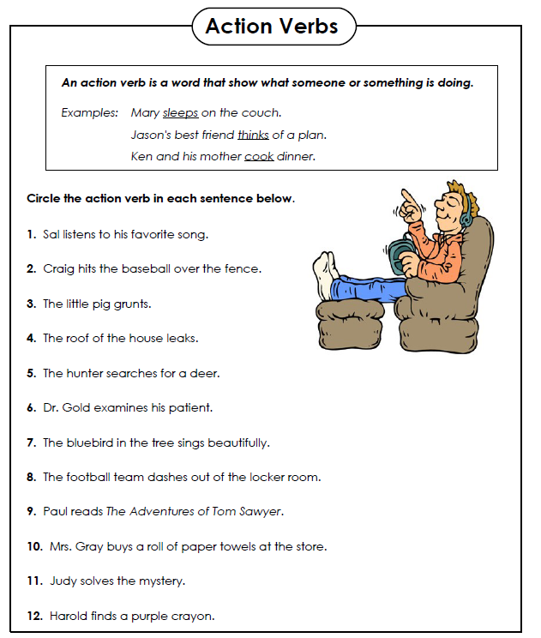
Name:

Write a sentence with an action verb to describe each picture. Underline the action verb.

1.

2.

3.

