ASSESSMENT PLAN 2017
COM-FSM Chuuk Campus

(1) General Structure of COM-FSM Assessment Requirements

COM-FSM has an extraordinarily complex system of assessment of everything COM-FSM. The nature of the complexity makes it extraordinarily difficult to implement everything. WASC/ACCJC does not try to tell any of its colleges how to self-improve, and so we are extraordinarily trapped in a spider-web of assessment. Full implementation must therefore depend on communications networking – between our Palikir administration and Chuuk Campus Community (top-down and bottom-up) and among our own departments and offices on campus.

The general structure of COM-FSM assessment requirements is shown below:

Administration President’s Cabinet
(Dean, IC, and SSC) System-Wide Committees
↓ ↓
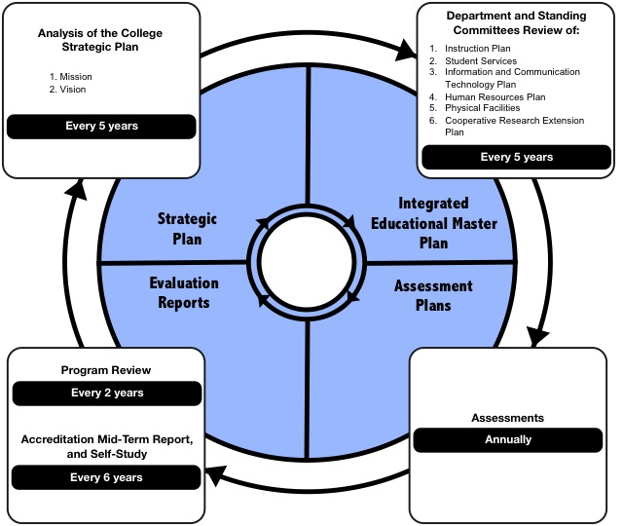
↑ ↑
Dean, IC, SSC Faculty and Staff

