College of Micronesia – FSM
All Campus Meeting)

Committee or Working Group: | Chuuk campus Students, faculty, and staff

Date: January 15.20 | Time: 12:00 p.m.-1:00 | Location: Student Activities Center
Attendance: 35 faculty and Staff, 55 Students

Additional Attendees/Guests | None

Discussio/Information Sharing:
- Emcee, Campus Dean Wilson Bisalen welcomed and thank all for attending this month’s all campus meeting of January 2020.
- Wilson asked reverend Mike Abbe for a word of prayer

- All who attended the meeting recited the College’s Mission Statement.
Updates from departments:
- IC reminds students that last day for Add and Drop today Jan 15, those who are part needs to add courses.
- Those who are interested in taking the 3rd year test must sign up.
- Trial counselor course not offer this semester, still needs students for the course
- Faculties needs to post their office hours on their window or door for student to see
CRE: Mike Abbe welcome everyone to spring 2020
- CRE will be hosting extension climate forum Monday Jan 20 at Kurassa
- Tuesday they will be visiting farm in the community
Student Services:
- COMET Testing at Chuuk campus February 1, must sign up at Admission if interested in taking
- College Nurse will have her first Influenza workshop on Jan 27
- Students with incomplete FAFSA must see FAO staff
- Students will elect new SBA officers, interested candidate must see Wilson
Miscellaneous:
- Vacancies announcement at Chuuk Campus
a. English Instructors
b. Computer Lab monitors
- Presentation for US Navy

- Adjournment at 1:00pm

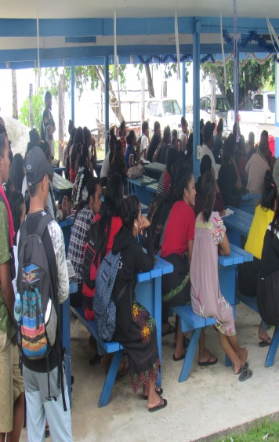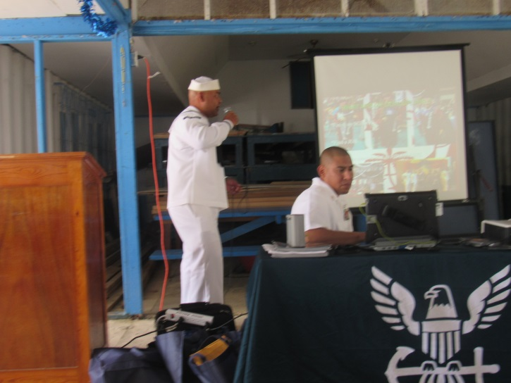

Prepared by:  Macleen Remit | Name and title of recording  Secretary II | Date Distributed:

Submitted by: |  | Date Submitted:

