College of Micronesia-FSM

2020 Turning Points:
Evaluation of Strategic Plan,
Mission & Values

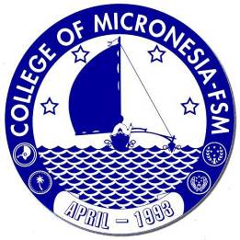

College of Micronesia-FSM
PO Box 159, Pohnpei, FM 96941

December 10th 2020

VPIEQA, OIE
Table of Contents
Figures and Tables 4
Abbreviations 5
Executive Summary 6
Part I: Strategic Plan 2018 – 2023 9
Strategic Direction I. Innovate academic quality to ensure student success 9
Strategic Measure I.1 All five CCSSE benchmarks are exceeded. 9
1.1.1. Explanation of Data 9
1.1.2. Results 10
1.1.3. Actions 11
Strategic Measure I.2 Institution-Set Standards Are Met 12
1.2.1. Explanation of Data 12
1.2.2. Results 13
1.2.3. Actions 14
Strategic Measure I.3 80% of students are enrolled full time 14
1.3.1. Explanation of Data 14
1.3.2. Results 14
1.3.3. Actions 15
Strategic Measure I.4 Average student semester credits earned is 12 15
1.4.1. Explanation of Data 15
1.4.2. Results 15
1.4.3. Actions 16
Strategic Measure I.5 Persistence rate (fall to spring) is 95% 17
1.5.1. Data Explanation 17
1.5.2. Results 17
1.5.3. Actions 18
Strategic Measure I.6 Persistence rate (fall to fall) is 80% 18
1.6.1. Data Explanation 18
1.6.2. Results 18
1.6.3. Action 19
Strategic Measure I.7 Graduation rate (100%) is 12% 19
1.7.1 Data Explanation 19
1.7.2. Results 20
1.7.3. Action 20
Strategic Measure I.8 Graduation rate (150%) is 29% 21
1.8.1. Data Explanation 21
1.8.2. Results 21
1.8.3. Action 22
Strategic Measure I.9 Graduation rate (200%) is 35% 22
1.9.1. Data Explanation 22
1.9.2. Results 23
1.9.3. Action 23
Strategic Direction II. Strengthen resources to meet current and future needs 24
Strategic Measure II.1 Operating costs reduced by 5% by innovating and streamlining services and processes 24
2.1.1. Data Explanation 24
2.1.2. Results 24
2.1.3. Actions 25
Strategic Measure II.2 Balanced budget maintained 25
2.2.1. Data Explanation 25
2.2.2. Results 25
2.2.3. Action 26
Strategic Measure II.3 Enrollment increased by 5% 26
2.3.1. Data explanation 26
2.3.2. Results 26
2.3.3. Action 28
Strategic Measure II.4 Reserve maintained at 40% 28
2.4.1. Data explanation 28
2.4.2. Results 28
2.4.3. Action 28
Strategic measure II.5 Current levels of government financial support are annually maintained or exceeded. 28
2.5.1. Data explanation 28
2.5.2. Results 28
2.5.3. Action 28
Strategic Measure II.6 Aggressive energy conservation measures in place reducing total annual cost by 20% 28
2.6.1. Data Explanation 29
2.6.2. Results 29
2.6.3. Actions 29
Strategic Measure II.7 Infrastructure upgraded in accordance with Phase I of the Facilities Master Plan 30
2.7.1. Data Explanation 30
2.7.2. Results 30
2.7.3. Actions 31
Strategic Measure II.8 Invest in employee development and capacity building to improve practices 31
2.8.1. Data explanation 31
2.8.2. Results 31
2.8.3 Action 31
Strategic Measure II.9 Average college employee attrition rate is less than 5% annually 32
2.9.1. Data explanation 32
2.9.2 Results 32
2.9.3 Action 32
Strategic Measure II.10 Employee job satisfaction survey yields overall 85% satisfaction rate 32
2.10.1. Data explanation 32
2.10.2. Results 34
2.10.3 Action 34
Strategic Measure II.11 Employee recruitment process is revamped to significantly reduce time from recruitment to hiring. 34
2.11.1 Data explanation 34
2.11.2. Results 35
2.11.3 Action 37
Part II. Mission & Values Review 38
3.1. Status of COM-FSM Mission Fulfillment Indicators 2020 38
3.2. COM-FSM Online Summit 2020 46
3.2.1 COM-FSM Mission Statement – Periodically Reviewed and Updated 46
3.2.2. Values review 47
3.3. External Community Stakeholder Mini-Summits 2020: Are We Living Up To Our Mission? 50
3.3 Recommendations for Consideration 52
3.3.1. Mission Statement 52
3.3.2. Mission Fulfillment Indicators 52
3.3.3. Values 52

Figures and Tables

Figure 1: Comparing the Nine Measures of Success in Strategic Direction I with COM-FSM's 13 Institution-Set Standards 11
Figure 2: COM-FSM Performance Against 13 Institution-Set Standards & Stretch Targets 2015-2020 12
Figure 3: Percentage of COM-FSM students enrolled full-time by campus 2016-2019 14
Figure 4: Average Number of Credits Earned by COM-FSM Students in Fall Semester 2015-2019, by Campus 15
Figure 5: COM-FSM Collegewide Enrollment AY2015-2016 to AY2019-2020 22
Figure 6: COM-FSM Number of Students Enrolled by Campus AY2015-16 to AY2019-2020 22
Figure 7: COM-FSM's Total Collegewide Electricity Consumption in Kilowatt-Hours 2010-2018 24
Figure 8: Percentage of College Members who Do NOT Agree that Values are Shown Through College Actions 43

Table 2: Percentage of COM-FSM students enrolled full-time 2015-2020 13
Table 3: Percentage of COM-FSM students enrolled full-time by campus 2016-2019 14
Table 4: Average number of credits earned by COM-FSM students in Fall semesters 2015-2020 15
Table 5: Average number of credits earned by COM-FSM students in Fall semester 2015-2020, by Campus 15
Table 6: Percentage of Students Who Continued to Study at COM-FSM from Fall to Spring, 2015-2019, Collegewide 16
Table 7: Percentage of Students Who Continued to Study at COM-FSM from Fall to Spring, 2015-2019, by Campus 16
Table 8: Fall to Fall Persistence Rate 2015 - 2018 17
Table 9: COM-FSM Total Operating Costs 2016-2019 20
Table 10: Comparison of Commercial Surveys of Employee Satisfaction 28
Table 11: Time Between Vacancy Closing Date and the Date of Transmitting the Application Packets to Ad Hoc Committees, FY2020 30
Table 12: Time Between Final Interview & Ad Hoc Committee Making a Hiring Recommendation to HRO, FY2020 31
Table 13: Fulfillment of Local, National, and Regional Mission Fulfillment Indicators, December 2020 33
Table 14: Achievement & Trend Data of Mission Fulfillment Indicators, 2017 - 2020 39
Table 15: Online State Mini-Summits Dates & Participants 45

Abbreviations

ACCJC Accrediting Commission for Community and Junior Colleges
AY Academic Year
CCSSE Community College Survey of Student Engagement
COM-FSM College of Micronesia-FSM
CTE Certificate of Teacher Education
CTEC Career and Technical Education Center (previously, Pohnpei campus)
eNPS Employee Promoter Score Survey
FSM Federated States of Micronesia
FSM-FMI Federated States of Micronesia-Fisheries and Maritime Institute
FY Financial Year (October 1st to September 30th)
HRO Human Resources Office
ICs Instructional Coordinators
IEQA Institutional Effectiveness and Quality Assurance
IPEDS Integrated Postsecondary Education Data System
ISS Institution Set Standards
NCCBP National Community College Benchmark Project
OIAEA Office of Institutional Advancement & External Affairs
OIE Office of Institutional Effectiveness
SENSE Survey of Entering Student Engagement
SIS Student Information System (MyShark)
SSC Student Success Committee
PPEC Pacific Postsecondary Education Council
PPMO Procurement and Property Management Office
PPR Personnel Position Requisition
VP Vice President
USDE United States Department of Education

Executive Summary

The College of Micronesia-FSM is a learner-centered institution of higher education that is committed to the success of the Federated States of Micronesia by providing academic and career & technical educational programs characterized by continuous improvement and best practices.

As part of its planning processes, COM-FSM has a Strategic Plan 2018 - 2023 that aims to establish the future of the college and help the college fulfill its mission.

This report serves as a mid-term review of the Strategic Plan and consists of two main parts.

- Part I of this report analyzes data on the two strategic directions and 20 measures of success, covering the period from Fall 2016 to Fall 2020 where possible, to provide the perspective of longitudinal data and trends.

- Part II focuses on a broad-based participatory review of the college mission and values. This includes 24 mission fulfillment indicators (qualitative and quantitative data), disaggregated by campus when possible.

Part I
COM-FSM’s Strategic Plan 2018-2023 consists of two strategic measures. Within Strategic Measure I ‘Innovate academic quality to ensure student success’, 3 of 9 measures of success has been attained. In large part, this is because the Strategic Plan 2018-2023 raised the bar, taking what was previously known as ‘stretch’ targets, or ambitious long-term goals, and setting them as the new standard. Within Strategic Measure II ‘Strengthen resources to meet current and future needs’. 2 of 11 measures of success have been attained, largely in the area of fiscal responsibility. Four measures have not been met. Five measures of success are lacking current or baseline data.

Strategic Measures of Success = met = not met

Strategic Direction 1: Innovate academic quality to ensure student success’ | 1.1 All five CCSSE benchmarks are exceeded
 | 1.2 Institution-Set Standards Are Met (9/13)
 | 1.3 80% of students are enrolled full time
 | 1.4 Average student semester credits earned is 12
 | 1.5 Persistence rate (fall to spring) is 95%
 | 1.6 Persistence rate (fall to fall)is 80%
 | 1.7 Graduation rate (100%) is 12%
 | 1.8 Graduation rate (150%) is 29%
 | 1.9 Graduation rate (200%) is 35%
TOTAL 3 of 9 measures met - 33%
6 of 9 measures not met - 67%
Strategic Measure II: Strengthen resources to meet current and future needs | 2.1 Operating costs reduced by 5% by innovating ad streamlining services and processes
 | 2.2 Balanced budget maintained
 | 2.3 Enrollment increased by 5%
 | 2.4 Reserve maintained at 40%
 | 2.5 Current levels of government financial support are annually maintained or exceeded
 | 2.6 Aggressive energy conservation measures in place reducing total annual cost by 20%
 | 2.7 Infrastructure upgraded in accordance with Phase I of the Facilities Master Plan
 | 2.8 Invest in employee development and capacity building to improve practices.
 | 2.9 Average college employee attrition rate is less than 5% annually.
 | 2.10 Employee job satisfaction survey yields overall 85% satisfaction rate.
 | 2.11 Employee recruitment process is revamped to significantly reduce time from rcruitent to hiring.
TOTAL 2 of 11 measures met - 18%
4 of 11 measures not met - 36%
5 of 11 measures lacking updated data - 45%

Part II

COM-FSM has achieved 18 (or 75%) of its 24 mission indicators, and minimally achieved 2 (8.3%) of its 24 mission indicators. 83.3% of indicators are met, exceeding the required 17 indicators (71%) necessary for mission fulfillment.

COM-FSM is considered to be fulfilling its mission provided no more than seven (29%) of the 24 total indicators are at the ‘not achieved’ level so that the college attains at least 17 (71%) of its indicators within the achieved or minimally achieved range.

The following two indicators are minimally achieved:
- Fall-to-spring persistence rate
- Fall-to-fall persistence rate

Four indicators are not achieved:
- Academic challenge benchmark
- Student faculty interaction benchmark
- Number of degrees awarded
- Transfer rate

IEQA conducted workshops for members of the community in each State and included participants from State Congressional representatives, Department of Education, and local business leaders, among others. Together, they considered the mission fulfillment indicators and tried to answer the question “Are we living up to our mission?’.

Part I: Strategic Plan 2018 – 2023

Strategic Direction I. Innovate academic quality to ensure student success

Ensure student success by decreasing time to completion and increasing student satisfaction, persistence, retention, and graduation rates by innovating academic quality and enhancing student support services.

Ensure student success by… | Strategic Measures
Decreasing time to completion | 1.3, 1.4, 1.5, 1.6, 1.7, 1.8, 1.9
Increasing student satisfaction | 1,1
Increasing persistence | 1.5, 1.6
Increasing retention | 1.5, 1.6
Table 1: Mapping Strategic Direction I to Strategic Measures of Success
Measure of success number 1.2 is “Institution Set Standards are met”. The ambitious longer-term goals previously named as “Stretch Goal” within the Institution Set Standards have in most cases become the target for the strategic measures in the 2018-2023 plan.

To measure performance of Strategic Direction I, and in compliance with US Department of Education (USDE) regulations and accreditation standards, the college established Institution-Set Standards (ISS) of performance and developed stretch targets for improvement over the five years of the Strategic Plan. ISS were derived from longitudinal institutional performance data and represent an institutional commitment to perform above these set standards at all times.

Strategic Measure I.1 All five CCSSE benchmarks are exceeded.

Explanation of Data

The Community College Survey of Student Engagement (CCSSE) is an assessment tool that provides information on student engagement, a key indicator of learning and, therefore, of the quality of community colleges. The survey is comprised of items that assess institutional practices and student behaviors that are highly correlated with student learning and student retention. It is a versatile, research-based tool appropriate for multiple uses. Identifying what students do in and out of the classroom, knowing students' goals, and understanding external responsibilities can help the college create an environment that can enhance learning, development, and success.

COM-FSM administers CCSSE every two years: 2016, 2018, 2020, and 2022.

The survey is usually administered in the Spring semester with results made available in Fall. The next CCSSE administration will be in 2022.

Results

Not met.

2016 Benchmark Scores report:
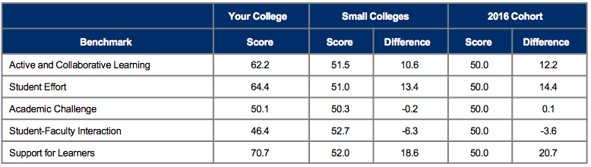

2018 Benchmark Scores report:
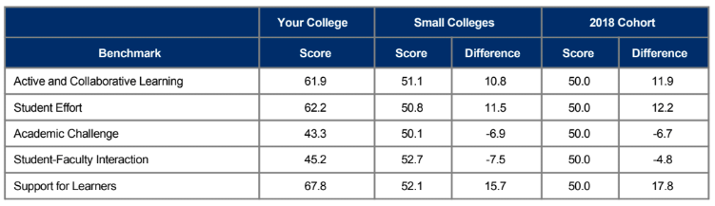

2020 Benchmark Scores report:
 | Your College | Small Colleges |  | 2020 Cohort
Benchmark | Score | Score | Difference | Score | Difference
Active and Collaborative Learning | 61.1 | 51.4 | 9.7 | 50.0 | 11.1
Student Effort | 63.0 | 50.9 | 12.1 | 50.0 | 13.0
Academic Challenge | 44.5 | 50.3 | -5.7 | 50.0 | -5.5
Student-Faculty Interaction | 46.4 | 53.0 | -6.6 | 50.0 | -3.6
Support for Learners | 67.7 | 52.0 | 15.7 | 50.0 | 17.7

- CCSSE scores across all five areas decreased between 2016 and 2018, with some minor increase seen in 2020 (Student Effort, Academic Challenge and Student-Faculty Interaction)

- Within three areas, COM-FSM performs above the benchmarks of small colleges across the US: Active & Collaborative Learning, Student Effort, and Support for Learners.

- In two areas, Academic Challenge, and Student-Faculty Interaction, COM-FSM is underperforming compared to the small college benchmark.

Actions

Student Success Committee were tasked with analyzing the 2018 CCSSE results in detail. They decided that the student-faculty interaction was the most important area, and in particular, noted academic guidance / counselling as needing attention. They created a survey to understand student perceptions and understanding of the role of academic advisors. This was included as an additional component in CCSSE 2020.

In 2020, SSC are tasked with analyzing the results of this component.

During Fall 2020, the College of Micronesia-FSM administered the Survey of Entering Student Engagement (SENSE), a survey that focuses on first-time (new) entering students. This survey aims to focus on students’ experiences in the critical first few weeks of college. Grounded in research about what works in retaining and supporting entering students, SENSE collects and analyzes data about institutional practices and student behaviors. Students respond to the survey and participating colleges receive survey reports including data and analysis they can use to improve their programs and services for entering students. Specifically, SENSE data can be used in improving course completion rates and the rate at which students persist beyond the first term of enrollment.

The SENSE was administered during the fourth and fifth weeks of the fall academic term to students in courses randomly selected from those most likely to enroll entering students. Due to COVID-19 and the move to online learning, the SENSE administration was switched from paper survey to online. A major collaborative effort was made between OIE and Counseling services to encourage students to take the survey. As of November 13th 2020, out of 663 new entering students, 294 (44%) opened the survey but only 183 (28%) completed the survey. While awaiting the results, we will reflect upon our experiences in administering the survey to inform future decision-making regarding the SENSE survey, the value of the data collected, and student engagement for first-time students.

Strategic Measure I.2 Institution-Set Standards Are Met

1.2.1. Explanation of Data
The college established 13 institution-set standards with medium (1-3 years) and long-term (5 years – “Stretch”) targets for improvement. Nine of the long-term (‘stretch’) targets for improvement became the measures of success within the Strategic Plan 2018-2023 Strategic Direction I.

13 Institution-Set Standards are updated every quarter on COM-FSM’s Institution-Set Standards & Mission Fulfillment Indicators webpage.
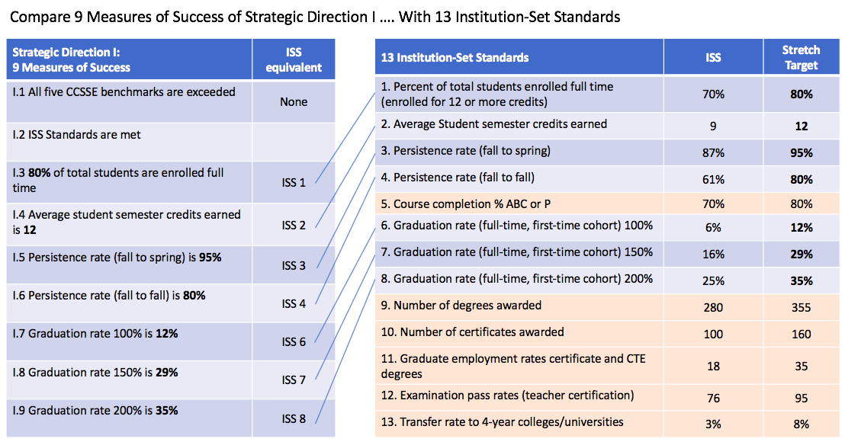

Figure 1: Comparing the Nine Measures of Success in Strategic Direction I with COM-FSM's 13 Institution-Set Standards

Figure 1 above shows that six Institution-Set Standards (highlighted in pink) are not included in the Strategic Measures of success.

This section focuses on COM-FSM’s achievements of the 13 Institution-Set Standards as a whole. A more detailed view of Institution-Set Standards #1-8 (which correspond to Strategic Measures I.3 – I.9) are provided in the corresponding sections of the report.

1.2.2. Results

9 of 13 targets met – 69% met.

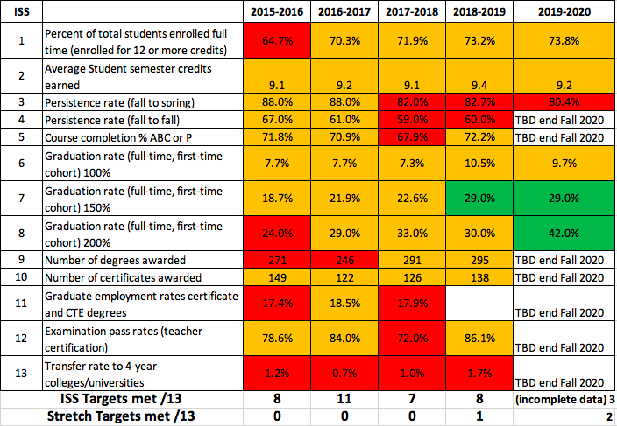
Figure 2: COM-FSM Performance Against 13 Institution-Set Standards & Stretch Targets 2015-2020
- 2016-2017 shows the highest performance against the Institution-Set Standards, with a total of 11 targets met.
- Progress in graduation rates has met two of the longer-term “stretch” targets.
- Persistence rates are generally on a downward trend.
- Little progress has been made in ISS 13 – transfer rate to 4-year colleges/universities.

1.2.3. Actions
- Collaboration between OIAEA and OIE to create an action plan with alumni, and the need to better track COM-FSM alumni and employment data.
- Data tracking issue – needs addressing.
- Learning from Program Review what individual Programs are already doing in terms of tracking program alumni

Strategic Measure I.3 80% of students are enrolled full time

1.3.1. Explanation of Data

A student who is enrolled for 12 credits or more is considered full-time. The Office of Institutional Effectiveness (OIE) extracts data from the Student Information System (MyShark) to calculate the percentage of students who are enrolled for 12 credits or more, based on Fall semester data.

1.3.2. Results

Not met.

Collegewide data shows that the Institution-Set Standard of 70% students enrolled full-time has been consistently met since 2016. However, Strategic Measure I.3 aims to meet the Stretch target of 80% - this has not yet been met at college level.

 | 2015-2016 | 2016-2017 | 2017-2018 | 2018-2019 | 2019-2020
Percent of total students enrolled full time | 64.7% | 70.3% | 71.9% | 73.2% | 73.8%
Table 2: Percentage of COM-FSM students enrolled full-time 2015-2020
The data below shows significant differences by campus. Full-time enrollment is highest at National campus and has been varying at other campuses. For example, the percentage of full-time students enrolled at Kosrae campus has increased significantly since 2016 whereas full-time enrollment at Chuuk campus has been relatively stable currently at 65.5%.

Figure 3: Percentage of COM-FSM students enrolled full-time by campus 2016-2019

 | Chuuk | CTEC | Kosrae | National | Yap
2016 | 64.4% | 56.8% | 40.4% | 88.0% | 59.2%
2017 | 68% | 60% | 49% | 85% | 60%
2018 | 68.8% | 62.3% | 63.6% | 84.5% | 54.4%
2019 | 65.5% | 64.8% | 57.6% | 85.2% | 55.1%
Table 3: Percentage of COM-FSM students enrolled full-time by campus 2016-2019

1.3.3. Actions
- Possibility of setting “Campus-set standards” aligned with both Institution-Set Standards and the unique characteristics of each campus

- Should this be adjusted in line with online learning? Targeting non-traditional students and part-timers?

Strategic Measure I.4 Average student semester credits earned is 12

1.4.1. Explanation of Data

The Office of Institutional Effectiveness (OIE) extracts data from the Student Information System (MyShark) to calculate the average number of credits earned, based on Fall semester data.

1.4.2. Results

Not met.
Collegewide data shows that the Institution-Set Standard of 9 credits per student in one semester has been consistently attained in Fall semesters since 2015.

However, Strategic Measure I.4 aims to meet the Stretch target of 12 credits - this has not yet been met at college level.

 | 2015-2016 | 2016-2017 | 2017-2018 | 2018-2019 | 2019-2020
Average Student semester credits earned | 9.1 | 9.2 | 9.1 | 9.4 | 9.2
Table 4: Average number of credits earned by COM-FSM students in Fall semesters 2015-2020
The data below shows differences by campus. Since 2015, the average number of credits earned by COM-FSM students at National campus in Fall semesters has been slowly declining, whereas at CTEC there has been a gradual increase.

 | Chuuk | CTEC | Kosrae | National | Yap
2015 | 8.6 | 8.0 | 6.4 | 10.2 | 9.2
2016 | 9.1 | 8.1 | 7.0 | 10.4 | 8.9
2017 | 9.5 | 8.1 | 7.2 | 9.6 | 10.6
2018 | 10.1 | 8.3 | 8.8 | 9.9 | 9.4
2019 | 9.4 | 8.4 | 7.3 | 9.7 | 9.9
Table 5: Average number of credits earned by COM-FSM students in Fall semester 2015-2020, by Campus

Figure 4: Average Number of Credits Earned by COM-FSM Students in Fall Semester 2015-2019, by Campus

1.4.3. Actions

???

Strategic Measure I.5 Persistence rate (fall to spring) is 95%

1.5.1. Data Explanation

When a student enrolls at COM-FSM, we hope that they will continue their studies through to completion. Persistence rate measures the percentage of students who enrolled for the first time (not returning students), as full-time students, in Fall semester – who are still enrolled in the next semester (Spring) of the same year. This data is extracted from the SIS.

- If a student transfers to another institution of higher education, we count this as ‘persisted’, since they are continuing their studies, even though they are no longer with COM-FSM.
- If a student starts their studies at one of the State campuses and later transfers to another campus within the COM-FSM system, we count this this as ‘persisted’, since they are continuing their studies at COM-FSM.

The Institution Set-Standard aims that 87% of these students are still enrolled in the next Spring semester. Strategic measure I.5 is equivalent to the stretch target –95% of these students are still enrolled in the Spring semester.

1.5.2. Results

Not met.

Collegewide data shows that neither the Institution-Set Standard of 87% nor the Stretch target of 95% (equivalent to Strategic Measure I.5) persistence rate (fall to spring) has been met since academic year 2017-2018.

 | 2015-2016 | 2016-2017 | 2017-2018 | 2018-2019 | 2019-2020
Persistence rate (fall to spring) | 88.0% | 88.0% | 82.0% | 82.7% | 80.4%
Table 6: Percentage of Students Who Continued to Study at COM-FSM from Fall to Spring, 2015-2019, Collegewide

 | Chuuk | CTEC | Kosrae | National | Yap
2015 | 85.7% | 87.8% | 76.2% | 91.2% | 92.0%
2016 | 86.8% | 82.9% | 78.8% | 89.7% | 75.0%
2017 | 81.0% | 80.8% | 71.4% | 86.9% | 89.6%
2018 | 85.4% | 77.1% | 80.4% | 88.4% | 83.3%
2019 | 91.3% | 82.7% | 75.6% | 85.8% | 85.7%
Table 7: Percentage of Students Who Continued to Study at COM-FSM from Fall to Spring, 2015-2019, by Campus

1.5.3. Actions

???

Strategic Measure I.6 Persistence rate (fall to fall) is 80%

1.6.1. Data Explanation

Similar to Strategic measure I.5, Persistence rate (fall to fall) aims that 80% of full-time first time students are still enrolled in the next academic year semester.

The Institution Set-Standard aims that 61% of these students are still enrolled the next academic year Fall semester. Strategic measure I.6 is equivalent to the stretch target – 80% of these students are still enrolled in the Fall semester.

1.6.2. Results

Not met.

COM-FSM has not yet met the target of 80% fall-to-fall persistence rate. Persistence rates are quite variable year on year, both within and across campuses.

 | Chuuk | CTEC | Kosrae | National | Yap | Collegewide
2015 | 62.9% | 55.1% | 57.1% | 79.2% | 52.0% | 64.0%
2016 | 48% | 57% | 58% | 70% | 53% | 60%
2017 | 50% | 53% | 48% | 66% | 60% | 57%
2018 | 64% | 55% | 43% | 73% | 54% | 62%
Table 8: Fall to Fall Persistence Rate 2015 – 2018

Figure 5: Percentage of First-Time Full-Time Students Who Continued their Studies in the Next Academic Year by Campus, Compared to Collegewide Average ("fall-to-fall persistence rate")

1.6.3. Action

Strategic Measure I.7 Graduation rate (100%) is 12%

1.7.1 Data Explanation

Graduation rate data provide information on institutional productivity and help institutions comply with reporting requirements of the Student Right-to-Know Act (1990) and the Higher Education Act, amended (2008).

Following the IPEDS definition, graduation rates data are collected for full-time, first-time degree and certificate-seeking undergraduate students.

100% in Strategic Measure I.7 refers to the time it normally takes a student to complete a program; a full-time student should be able to complete all the requirements for an Associate’s degree within two years. Strategic measure I.7 calculates the percentage of students who enrolled as full-time, first-time students who graduated within two years.

The Institution-Set Standard for graduation rate (100%) is 6%. The Stretch Target was set at 12%. Strategic Measure I.7 took the stretch target as the new goal.

1.7.2. Results

Not met.

 | 2016-2017 | 2017-2018 | 2018-2019 | 2019-2020
Chuuk | 0.6% | 1.0% | 0.2% | 0.4%
CTEC | 4.4% | 1.9% | 1.8% | 1.6%
Kosrae | 0.2% | 0.2% | 0.0% | 0.0%
National | 1.8% | 3.5% | 0.4% | 7.5%
Yap | 0.9% | 0.6% | 1.1% | 0.2%
Collegewide | 7.9% | 7.3% | 3.4% | 9.7%

Figure 6: Percentage of First-Time Full-Time COM-FSM Students who Graduated in 2 years, by Campus

1.7.3. Action

- Wording of this measure confuses many people. To make it more reader-friendly, change to “12% of full-time first-time students graduate in 2 years”
- How many full-time students are actually aiming to complete in 2 years? What about the 30% or more part-time students and their goals?
- This measure also doesn’t account for Certificate students well – the measures states “100%” is 2 years, whereas a Certificate should only take one year.

Strategic Measure I.8 Graduation rate (150%) is 29%

1.8.1. Data Explanation

Following the IPEDS definition, graduation rates data are collected for full-time, first-time degree and certificate-seeking undergraduate students.

150% in Strategic Measure I.8 refers to the time it normally takes a student to complete a program; a full-time student should be able to complete all the requirements for an Associate’s degree within two years – if they take 150% of that time, it will take them three years to complete. Strategic measure I.8 calculates the percentage of students who enrolled as full-time, first-time students who graduated within three years.

The Institution-Set Standard for graduation rate (150%) is 16%. The Stretch Target was set at 29%. Strategic Measure I.8 took the stretch target as the new goal.

1.8.2. Results

Met.

 | 2016-2017 | 2017-2018 | 2018-2019 | 2019-2020
Chuuk | 0.7% | 1.7% | 1.6% | 3.6%
CTEC | 7.5% | 4.0% | 7.8% | 8.5%
Kosrae | 0.2% | 0.4% | 0.5% | 1.0%
National | 9.7% | 15.2% | 10.5% | 13.7%
Yap | 1.3% | 0.6% | 2.2% | 1.8%
Collegewide | 19.4% | 21.9% | 22.6% | 28.6%

Figure 7: Percentage of First-Time Full-Time COM-FSM Students who Graduated in 3 years, by Campus

1.8.3. Action

- Wording of this measure confuses many people. To make it more reader-friendly, change to “29% of full-time first-time students graduate in 3 years”
- This measure also doesn’t account for Certificate students well – the measures states “100%” is 2 years, whereas a Certificate should only take one year.

Strategic Measure I.9 Graduation rate (200%) is 35%

1.9.1. Data Explanation

Following the IPEDS definition, graduation rates data are collected for full-time, first-time degree and certificate-seeking undergraduate students.

200% in Strategic Measure I.9 refers to the time it normally takes a student to complete a program; a full-time student should be able to complete all the requirements for an Associate’s degree within two years – if they take 200% of that time, it will take them four years to complete. Strategic measure I.9 calculates the percentage of students who enrolled as full-time, first-time students who graduated within four years.

The Institution-Set Standard for graduation rate (200%) is 25%. The Stretch Target was set at 35%. Strategic Measure I.9 took the stretch target as the new goal.

1.9.2. Results

Met.

 | 2016-2017 | 2017-2018 | 2018-2019 | 2019-2020
Chuuk | 1.7% | 2.1% | 2.5% | 5.2%
CTEC | 8.1% | 4.6% | 10.5% | 10.7%
Kosrae | 0.2% | 0.6% | 0.7% | 1.2%
National | 12.5% | 25.3% | 13.4% | 21.0%
Yap | 1.5% | 0.6% | 2.7% | 3.8%
Collegewide | 23.9% | 33.2% | 29.9% | 41.9%

Figure 8: Percentage of First-Time Full-Time COM-FSM Students who Graduated in 4 years, by Campus

1.9.3. Action

- Wording of this measure confuses many people. To make it more reader-friendly, change to “35% of full-time first-time students graduate in 4 years”
- This measure also doesn’t account for Certificate students well – the measures states “100%” is 2 years, whereas a Certificate should only take one year.

Strategic Direction II. Strengthen resources to meet current and future needs

Strengthen resources to meet current and future needs through revenue diversification, efficient use, innovation, effective allocation, conservation, infrastructure upgrades, and investment in human capital.

Strengthen resources to meet current and future needs through… | Strategic Measures
Revenue diversification | 2.5
Efficient use of revenue | 2.1, 2.4,
Innovation | 2.3
Effective allocation | 2.2
Conservation | 2.6
Infrastructure upgrades | 2.7
Investment in human capital | 2.8, 2.9, 2.10, 2.11

Strategic Measure II.1 Operating costs reduced by 5% by innovating and streamlining services and processes

2.1.1. Data Explanation

This Strategic Measure uses the total operating costs of COM-FSM as reported within the annual audit reports prepared by Deloite & Touche LLP. Operating expenses include Institutional support, Instruction, Student financial assistance, Student services, Depreciation, Auxiliary enterprises, Academic support, and Operations and maintenance, plant.

2.1.2. Results

Not met.
Total operating costs for 2018 were 7.4% lower than they were in 2016, or 2.5% lower than in 2017.

Total operating costs increased in 2019.The operating costs of 2019 were 0.6% higher in 2019 than they were in 2016, and 6% higher than in 2017.

Financial Year | Total Operating Cost
2016 | $20,959,189
2017 | $19,891,058
2018 | $19,402,005
2019 | $21,087,852
Table 10: COM-FSM Total Operating Costs 2016-2019

2.1.3. Actions

The original wording of Strategic Measure of success II.1 did not state which year to use as baseline data. Recommend to use 2017, the year prior to the beginning of the Strategic Plan as the baseline year.

Does it make sense to use this particular figure?
Why are we talking about decreasing operating expenses at the same time as increasing enrollment and retention? Should the calculation be changed? And perhaps the Strategic Measure wording be something like “Operating costs per capita are reduced by 5% from 2018.” (Calculated using the cost + Total number of students (headcount) + Admin staff + Faculty)

Strategic Measure II.2 Balanced budget maintained

2.2.1. Data Explanation

A balanced budget means that the expenses of COM-FSM will be equivalent to projected revenue and that any variances are addressed immediately in order not to affect the cash flow. A balanced budget during the fiscal year is demonstrated when the college is able to complete its operations without using its cash reserved.

Each year, the budget is created and approved according to the latest Budget Procedures Handbook for the financial year after next. For example, in 2020 the FY2022 budget was approved at the December Board of Regents meeting.

2.2.2. Results

Met.

FY2022 – balanced budget approved as reported in Board of Regents 3rd December 2020 meeting

FY2021 – balanced budget approved as reported in Board of Regents 27th November 2019 meeting.

FY2020 – balanced budget approved as reported in Board of Regents 5th December 2018 meeting

FY2019 – balanced budget approved as reported in Board of Regents 13th December 2017 meeting

FY2018 - balanced budget approved as reported in Board of Regents 1st December 2016 meting

2.2.3. Action

None.

Strategic Measure II.3 Enrollment increased by 5%

2.3.1. Data explanation

Enrollment measures the number of people enrolled for credits at COM-FSM. There are various ways to measure enrollment, for example, the number of students enrolled in credit courses in the fall semester or alternatively, the total number of credits that students have enrolled in. For Strategic Measure II.3, COM-FSM uses the total headcount of students enrolled in each academic year. If a student is enrolled for more than one semester, they are only counted once – this is called ‘unduplicated headcount’.

Data from AY2015-2016 is presented here to demonstrate trend data.
Headcount from FSM-FMI is not included here because…?..

2.3.2. Results

Not met.

Figure 9: COM-FSM Collegewide Enrollment AY2015-2016 to AY2019-2020
- Collegewide enrollment in AY2019-2020 has decreased by 12.75% compared to AY2015-2016.
- Collegewide enrollment in AY2019-2020 has decreased by 8.4% compared to AY2017-2018.

Figure 10: COM-FSM Number of Students Enrolled by Campus AY2015-16 to AY2019-2020
Considering each campus:

- the sharpest decline in enrollment is at CTEC campus with a 39% decrease over the five years reported.
- Enrollment at Chuuk campus has increased by 28.6%
- Both Kosrae and Yap campus have seen slow and steady declines in enrollment, 26.6% and 29.9% respectively
- National campus has maintained relatively stable enrollment – a 3% increase since AY2015-2016.

2.3.3. Action

???

Strategic Measure II.4 Reserve maintained at 40%

2.4.1. Data explanation

2.4.2. Results

2.4.3. Action

Strategic measure II.5 Current levels of government financial support are annually maintained or exceeded.

2.5.1. Data explanation

2.5.2. Results

2.5.3. Action

Strategic Measure II.6 Aggressive energy conservation measures in place reducing total annual cost by 20%

2.6.1. Data Explanation
Data on electricity consumption is collected by the Facilities and Maintenance Office using the electricity bill. Data from all six campuses is aggregated to provide the total kilowatt hour consumption for COM-FSM.

2.6.2. Results

Met.

Figure 11: COM-FSM's Total Collegewide Electricity Consumption in Kilowatt-Hours 2010-2018

Results shows an overall decrease in electricity consumption across COM-FSM.

2.6.3. Actions
Facilities and Maintenance Office implemented an energy conservation and monitoring program including:
- Installation of LED lights
- Replace air conditioning units using Freon R22

Wording of strategic measure II.6 aims to reduce costs associated with COM-FSM’s energy use. Yet the cost of electricity is outside of control of COM-FSM. Suggest to change wording to “Aggressively conserve energy to lower kWhr consumption by 20% from baseline of 2017.”

Does COM-FSM’s electricity consumption go down according to student population?

Does this strategic measure still make sense in the COVID-19 context with students not coming onto campus?
Should the data be reported by campus (disaggregated) so we can see more clearly increases and decreases?

Strategic Measure II.7 Infrastructure upgraded in accordance with Phase I of the Facilities Master Plan

2.7.1. Data Explanation
In 2013, COM-FSM engaged Beca International Consultants Ltd (Beca) to create FSM Facility Master Plans in accordance with the college’s Five-Year Financial plan and the Integrated Educational Master Plan. In 2018, a revised Five-Year Financial plan 2018-2022 was approved by the Board of Regents in September 2017.

Only major projects (over $XXXX ??) are included within the measure.

2.7.2. Results

Not met.

Six of the 14 projects are implemented.

Item | Campus | Project Descriptions | Status | Stage
1 | CTEC | Multitechnical Building & Classrooms | Implemented | Bid for Construction
2 | CTEC | Learning Resources Center
3 | CTEC | Infrastructure Upgrade | Implemented | Bid for Construction
4 | National | National Student Center | Implemented | Bid for Construction
5 | National | National Teaching Clinic | Implemented | Request for detailed design
6 | National | Infrastructure Upgrade
7 | Yap | Technical Building and Maintenance Building
8 | Yap | Infrastructure Upgrade
9 | Chuuk | Upgrade of Current Site | Not approved by BOR
10 | Chuuk | Design of Buildings 1, 2 & 4 |  | Request for rescoping of project
11 | Chuuk | Design of On-site road and utilities |  | Request for rescoping of project
12 | Kosrae | Multipurpose Building stage-1 | Implemented | Design Phase 70%
13 | Kosrae | Infrastructure Upgrade | Implemented | Design Phase 70%
14 | FSMI-FMI | Onsite building & Infrastructure Upgrades

The six projects that have been implemented were originally set for the first five years in the Facilities Study Phased Implementation Plan dated 2013.

2.7.3. Actions

??? How does this change with move to online learning? The plan was dated 2013 and we are still discussing 5 years, 8 years later.

Strategic Measure II.8 Invest in employee development and capacity building to improve practices

2.8.1. Data explanation

# of next qualifications attained eg. BA, Associates degrees earned while on the job.
$ spent on tuition?
Professional Development - I have limited data for now of the opportunities planned, coordinated and delivered by HRO only. My annual budget just for the National Campus for many years now stays at $25, 000 while each campus maintains their own and I don't always know. For report, we normally go to Business Office. Just this year, here are some data from my office:

2.8.2. Results

- funding MA degree for a Faculty
- Delivered policy training for ICs -November and another is scheduled for December, 2020
- Coordinated the Customer Services Pilot with HR reps and Director of PPMO ending December 30, 2020. Plan to adopt it for the college to manage
- Coordinated summer session of remote management for Management Team with Dr. Watson

2.8.3 Action

Strategic Measure II.9 Average college employee attrition rate is less than 5% annually

2.9.1. Data explanation

2.9.2 Results

2.9.3 Action

Strategic Measure II.10 Employee job satisfaction survey yields overall 85% satisfaction rate

2.10.1. Data explanation

Data has yet to be collected for Strategic Measure II.10. The pros and cons of various options were considered, including creating and administering an in-house survey or participating in an external survey.

In-House Survey |  | Commercial Survey
Pros | Cons | Pros | Cons
High customization | Time and resources associated with developing, testing, administering and analyzing the survey.  Unable to benchmark against peer and national data | Most allow a limited number of custom questions to the existing survey instrument  Some includes national and/or peer benchmarking data | Potential high cost – recurring each time the survey is administered

 | Purpose of Survey | Survey Package | Cost / Cost for 400+ at COM-FSM
1. Institutional Performance Survey (National Center for Higher Education Management Systems) | Measure staff satisfaction as part of a broader gauge of I.E.  100 items measure 8 dimensions of institutional performance  Student (s.). educational satisfaction; S. academic development; S. career development; Faculty & administrator employment satisfaction; Professional development / quality of the faculty; System openness & community interaction; Ability to acquire resources; Organizational health | Paper based (including return prepaid postage), survey analysis and a report summary  Institutions can add up to 20 questions.  National data are unavailable.  * Check if this is true (report was written in 2012) | $1600 for 100 questionnaires – ($150 per extra 50)  /  ~$2200 for COM  10% discount for NCHEMS members
2. Chronicle of Higher Education “Great Colleges to Work For” | 2-part survey: 1 audits institutional policies and practices; 1 measures faculty & staff satisfaction through 15-item survey | Online (?)  Expecting for an institution of COM-FSM’s size that all full-time staff would participate.  3 free reports: overall job satisfaction; supervisor relationship; higher ed trends report excerpt | Free to participate for US accredited institutions.  Extra cost – can include additional non-fulltime staff.  Benchmarking data at cost.  GCC paid $1650 to show more detailed reports in 2018
3. Noel-Levitz College Employee Satisfaction Survey | 70 items measuring 5 areas: campus culture and policies; institutional goals; involvement in planning and decision making; work environment; and demographics  Survey allows respondents to rate both the importance of many items and their satisfaction with these item so institutions can easily identify areas for improvement (items which respondents rate as highly important but that they are also dissatisfied with) | Online or pen/paper  Institutions can add up to 29 custom questions.  National data unavailable | $500 setup fee  $2.50 for up to 749 surveys  +$200 for paper or paper/online combo.  $1500
Table 11: Comparison of Commercial Surveys of Employee Satisfaction

In September 2020, another option was proposed by Watson Training & Development, an Employee Promoter Score survey (eNPS)

2.10.2. Results

NA

2.10.3 Action

Strategic Measure II.11 Employee recruitment process is revamped to significantly reduce time from recruitment to hiring.

2.11.1 Data explanation

COM-FSM’s employee recruitment process is defined in Board Policy 6006 and its accompanying Administrative Procedure No. 6066 “Kinds of Positions and Appointments”.

- Complete a Personnel Position Requisition (PPR) form and seek VP endorsement.
- HRO prepares and advertizes a job announcement based on the PPR
- The first time a job is advertised for a period of 30 days while a re-advertisement lasts 15 days.
- Office heads make recommendations to the Director of Human Resources on which five members should serve on a hiring Ad Hoc Committee for positions within their office
- HRO receives applications for candidates and sends completed application packets to the Ad Hoc Committee
- Ad Hoc committee screen applicants and conduct interviews
- Within two weeks after the last interview conducted, the Ad Hoc committee makes a hiring recommendation to Human Resources Office
- HRO and VP informs Office heads when a recommendation for hire has been approved
- Director of HR makes a job offer
- Director of HR notifies office heads and respective vice presidents for the starting date of new hires in their offices and departments.

The Human Resources Office tracks various data in the above process.

Strategic Measure II.11 presents data on item (e) and item (g) in the above process:

- (e) the time between vacancy closing date and the dates the packets are sent to the Ad Hoc Committee) and
- (g) the time between the last interview date and ad hoc committee making a hiring recommendation

2.11.2. Results

Table 12: Time Between Vacancy Closing Date and the Date of Transmitting the Application Packets to Ad Hoc Committees, FY2020
The table above shows that of 99 vacancies, HRO transmitted 54% of packets to Ad Hoc committees within one week of the vacancy closing date. There were three cases which took longer than 3 months.

Table 13: Time Between Final Interview & Ad Hoc Committee Making a Hiring Recommendation to HRO, FY2020

The above data shows that ad hoc committees are largely failing to meet the 2-week window in which to make a hiring recommendation to HRO. 55% of ad hoc committees take more than three weeks, of which 22% take more than three months.

2.11.3 Action

The following resolutions have been made and already in place at Chuuk, FSM-FMI, Kosrae and Yap campuses.

- Appointments to Ad Hoc Committees should be made prior to the close of an advertised position
- Access to applications is electronic and limited to committee members with a deadline of removal
- Ad hocs meeting and/or interviews across the campuses is through zoom or skype as much as possible to allow HR staff to join and to allow members to who maybe working from home (faculty). Meeting in person is fine as long as it meets the public health requirements of 6 people in one room but this will be only if this is the only option.
- Confidentiality agreement will be signed by all ad hoc committee members and disciplinary action issued for breaches
- Consider additional timelines for committee appointment to committee review period to reduce the time to a manageable timetable

Part II. Mission & Values Review

Mission Statement: The College of Micronesia-FSM is a learner-centered institution of higher education that is committed to the success of the Federated States of Micronesia by providing academic, career and technical educational programs characterized by continuous improvement and best practices.

The college mission and vision are reviewed at least every five years in accordance with COM-FSM’s Planning Cycle (IEMP, p. 5). A Strategic Planning Working Group completed a Mission Review and Recommendations report in 2017. Their recommendations were approved by the Board of Regents on March 8th 2017.

This part of the document presents the data used to determine how effectively the college is accomplishing its mission:
- Status of COM-FSM Mission Fulfillment Indicators
- Mission and values reviewed within the college’s 2020 online summit - 282 college participants
- State mini-summits: public participation and recommendations based upon COM-FSM’s fulfillment of mission indicators

Individual recommendations from each of the four State mini-summits were presented to the Board in December 2020.

3.1. Status of COM-FSM Mission Fulfillment Indicators 2020

COM-FSM has achieved 18 (or 75%) of its 24 mission indicators, and minimally achieved 2 ( 8.3% ) of its 24 mission indicators.
83.3% of indicators are met, exceeding the required 17 indicators (71%) necessary for mission fulfillment.
Local benchmarks are those created within FSM.
Regional benchmarks are those set in relation to other institutions of higher education in the Western Pacific, using data from the Pacific Postsecondary Education Council (PPEC).
“National” indicators refer to indicators which situate COM-FSM within the broader educational context of USA, using data collected and benchmarked externally, for example, NCCBP and CCSSE.

Mission Aspects | Local Benchmark Indicators |  | Regional Benchmark Indicators |  | National Benchmarks Indicators |  | Total Indicators
 | Achieved | Total | Achieved | Total | Achieved | Total | Achieved | Total | Percent Achievement
The College of Micronesia-FSM is a learner-centered institution of higher education | 1 | 1 | n/a | 0 | 4 | 6 | 5 | 7 | 71.4%
that is committed to the success of the Federated States of Micronesia | 5 | 6 | n/a | 0 | n/a | 0 | 5 | 6 | 83.3%
by providing academic, career and technical educational programs characterized by continuous improvement and best practices. | 5 | 5 | 4 | 5 | 1 | 1 | 10 | 11 | 90.1%
Total Indicators | 11 | 12 | 4 | 5 | 5 | 7 | 20 | 24 | 83.3%
Percent Achievement | 91.7% |  | 80% |  | 71.4% |  | 83.3%
Table 14: Fulfillment of Local, National, and Regional Mission Fulfillment Indicators, December 2020
Mission fulfillment is determined by the college meeting a minimum threshold. Achievement of each individual indicator is measured relative to a range based on a corresponding threshold level and represented by achievement status. In the table below,
- Green is achieved;
- Yellow is minimally achieved; and
- Red is not achieved.

Mission Statement Criteria | Measures of Success | Indicator Data | Threshold | Type of Threshold | Achievement Status  2017 | Achievement Status  2020
The College of Micronesia-FSM is a learner-centered institution of higher education | Academic Challenge Benchmark (CCSSE) | 2020 Score 44.5  2018 Score 43.3  2016 Score 50.1 | Green ≥ 50.0  Yellow = 47.0-49.9  Red < 47.0 | National benchmark
 | Student faculty interaction benchmark CCSSE) | 2020 Score 46.4  2018 Score 45.2  2016 Score 46.4 | Green = 50.0  Yellow = 47.0-49.9  Red < 47.0 | National benchmark
 | Support for learners benchmark (CCSSE) | 2020 Score 67.7  2018 Score 67.8  2016 Score 70.7 | Green = 50.0  Yellow = 47.0-49.9  Red < 47.0 | National benchmark
 | Percent credit hours taught by full time faculty  (NCCBP Report)  Note – 2020’s NCCBP report is based on 2018 data. | 2018 – 92.39%  2017 – 96.39%  2016 – 94.16%  2015 - 98.06% | Green = 75%  Yellow = 64-74.9%  Red < 64% | National benchmark
 | Average number of students per credit section  (NCCBP Report)  Note – 2020’s NCCBP report is based on 2018 data. | 2018 - 16.56  2017 – 17.36  2016 - 17  2015 - 16.32 | Green = 25.0  Yellow = 25.1-30  Red > 30 | National benchmark
 | Percent full time students (12 or more credits)  (NCCBP Report)  Note – 2020’s NCCBP report is based on 2018 data. | 2018 – 73.3%  2017 – 71.91%  2016 – 70.33%  2015 – 65.01% | Green = 70%  Yellow = 50-69%  Red < 50 | National benchmark
 | Average student semester credits earned (Institution Set Standard) | Fall 2019 – 9.2  Fall 2018 - 9.4  Fall 2017 – 9.1  Fall 2016 - 9.3 | Green = 9.0  Yellow = 8.7-8.9  Red < 8.7 | Local benchmark
that is committed to the success of the Federated States of Micronesia | College provides higher education (HE) access to all four states of the FSM  *Keeping in mind that not all factors are within the direct control of COM-FSM. However, the college is tasked with taking efforts to improve access and equity when there is imbalance in representation. | College 2017 | College 2019 | College 2020 | Census |  Difference  Chuukese | 16.0% | 20.1% | 18.3% | 47.3% | -29.%  Kosraean | 11.4% | 6.9% | 11.4% | 6.4% | +5%  Pohnpeian | 58.6% | 54.4% | 54.7% | 54.7% | 35.2% | +19.5%  Yapese | 13.3% | 14.1% | 14.8 % | 14.8% | 11.1% | +3.8%  Total | 99.3% | 99.5% | 99.2% | 100% | COM-FSM population by origin compared to 2010 census population of all four states:  Green = COM-FSM provides HE access to all four states and at least 10% of the college’s students will come from each FSM state.  Yellow = Direct access is provided, but less than 10% of the college’s students come from each FSM state; however college can document efforts to mitigate under-representation.  Red = Either direct access to all four states is not provided or there is one or more under-represented population for whom the college cannot document actions to mitigate imbalance. | Local benchmark
 | Number of certificates awarded (Institution Set Standard) | AY2019 – 2020 – 141 certificates awarded  AY2018-2019 – 138  AY2017-2018 - 126  AY2016-2017 - 122 | Green ≥ 100  Yellow = 90-100  Red < 90 | Local benchmark
 | Number of degrees awarded (Institution Set Standard) | AY2019-2020 - 257  AY2018-2019 - 295  AY2017-2018 - 291  AY2016-2017 - 246 | Green ≥ 280  Yellow = 260-279  Red < 260 | Local benchmark
 | Graduate Employment Rates: % of students that completed a CTE program and are employed in related field. (Institution Set Standard) | AY2017 – 2018 – 18%  AY2017-2018 – 17.9%  AY2016-2017 - 18.50%  *acknowledging local labor market challenges | Green ≥ 18%  Yellow = 14-17.9%  Red < 14% | Local benchmark
 | Teacher certification examination pass rate (Institution Set Standard) | AY2018-2019 – 86.1%  AY2017-2018 – 72.0%  AY2016-2017 - 84.0% | Green ≥ 76%  Yellow = 70-75.9%  Red < 70% | Local benchmark
 | Programs linked to FSM developmental priorities as specified in the FSM Strategic Development Plan (2004-2023) | Private Sector (1)  Agriculture (2)  Fisheries | FMI (3)  Education (3)  Tourism (1)  Environment (1)  Health (3)  Current total: 14 | Green = 5 or more programs linked to the FSM Strategic Development Plan  Yellow = 3-4 programs linked to the FSM Strategic Development Plan  Red <3 programs linked to FSM Strategic Development Plan | Local benchmark
by providing academic, career and technical educational programs characterized by continuous improvement and best practices. | Active and collaborative learning benchmark (CCSSE) | 2020 Score – 61.1  2018 Score 61.9  2016 Score 62.2 | Green ≥ 50.0%  Yellow = 47.0-49.9%  Red < 47.0 | National benchmark
 | Number of Guided pathways completed (local) | AY2018-2019 - 2  AY2017-2018 - 0  AY2016-2017 - 2 | Local: Each year the college will create at least 2 guided pathways for its two-year programs:  Green: ≥2  Yellow = 1  Red = 0 | Local benchmark
 | Graduation rate 100% (% of full-time first-time students who completed in 2 years) | COM-FSM will be at least in the median graduation rate in the Western Pacific (PPEC) and meet its ISS of 6%. IPEDS data Pacific median graduation rate 2% (2011 cohort).  AY2019-20 – 10%  AY2018-2019 – 10.5%  AY2017-2018 – 7.3%  AY2016--2017 - 7.7% | Green ≥ 6%  Yellow = 2-5.9%  Red < 2% | Regional benchmark
 | Graduation rate 150% (% of full-time first-time students who completed in 3 years) | COM-FSM will be at least in the median graduation rate in the Western Pacific (PPEC) and meet its ISS of 16.0%. IPEDS data Pacific median graduation rate 8% (2011 cohort).  AY2018-2019 – 29%  AY2017-2018 – 22.6%  AY2016--2017 - 21.9% | Green: ≥ 16%  Yellow = 8-15.9%  Red < 8% | Regional benchmark
 | Graduation rate 200% (% of full-time first-time students who completed in 4 years) | COM-FSM will be at least in the median graduation rate in the Western Pacific (PPEC) and meet its ISS of 25.0%. IPEDS data Pacific median graduation rate 18% (2011 cohort).  AY2019-2020 – 42%  AY2018-2019 – 30%  AY2017-2018 – 33%  AY2016--2017 - 29% | Green: ≥25%  Yellow = 12-24.9%  Red < 12% | Regional benchmark
 | Transfer rate | COM-FSM will meet its ISS of 3% and be at least at the median transfer rate in the larger Pacific (PPEC and Hawaii Community Colleges) (IPEDS data Pacific median transfer rate 10%).  AY2018-2019 – 1.7%  AY2017-2018 – 1.0%  AY2016--2017 - 0.74% | Green: ≥ 10%  Yellow = 3-9.9%  Red = <3% | Regional benchmark
 | Fall-to-spring persistence rate | Fall 2019-2020 – 80.4%  Fall 2018-2019 – 82.7%  Fall 2017-2018 – 82%  Fall 2016-2017 – 88% | Green ≥ 87.0%  Yellow = 70-86.9%  Red < 70% | Local benchmark
 | Fall-to-fall persistence rate | Fall 2018-2019 – 60%  Fall 2017-2018 – 59%  Fall 2016-2017 – 61% | Green ≥ 61%  Yellow = 55-60.9%  Red < 55% | Local benchmark
 | Course Completion Rate (% A, B, C, or P) | AY2018-2019 – 72.2%  AY2017-2018 – 67.9%  AY2016-2017 - 70.9% | Green > 70%  Yellow = 68-69.9%  Red < 68% | Local benchmark
 | Institution-wide Credit Grades  % Completed  (NCCBP Report) | 2018 – 92.26%  2017 – 90.64%  2016 – 92.39%  2015 - 94.0% | Green > 91%  Yellow = 84.5-91%  Red < 84.5% | Local benchmark
 | Meeting or exceeding Accreditation Standards  (ACCJC Reports) | Accreditation Status – US Regional Accreditation | Green = Regional accreditation without sanction  Yellow = Regional accreditation with warning status  Red = Regional accreditation with probation or show cause status | Regional benchmark
Table 15: Achievement & Trend Data of Mission Fulfillment Indicators, 2017 - 2020

3.2. COM-FSM Online Summit 2020

COM-FSM hosted its first Online Summit in August 2020. The first component of the summit was “COM-FSM Institutional Check-In”, and included a review of COM-FSM’s mission, mission fulfillment indicators, and values. Some campuses and departments set up working groups, either online, or socially distanced in-person, to bring together those who preferred to work in groups. Materials were presented online with participants asked to engage with the material and provide their inputs using surveymonkey. The complete report of 2020’s Online Summits is available here and includes all materials used.

COM-FSM Mission Statement – Periodically Reviewed and Updated

The findings in this section come from 2020’s online summit; 282 college members including faculty, staff, and administrators, participated in the online summit.

College community members know and understand the mission statement well.

- The broad educational purpose of the college to be to provide academic and career and technical education programs characterized by continuous improvement and best practices”

- The intended student population is recognized as FSM students and citizens as well as diverse groups in the community

- People understand that the types of degrees and credentials that COM-FSM offers are AA, AS, AAS, BS, and certificates. Some people answered “Degree and Certificates in academic and career and technical education programs” while others specified the programs available at their respective campuses.

Open comments on the question “COM-FSM’s mission statement describes our commitment to student learning” included:

- Implicit: only in the phrase “learner-centered”
- The college is viewed as an ideal institution for best practices demonstrated through excellence, fineness and honesty of both employees and graduates.
- Based on external rumors, quality of our students are direct results of the high school they come from
- It only describes the commitment to the success of the FSM, but not student learning
- We might do more to strengthen existing cultures, eg. preventing language loss by creating pathways for scholarly and study of local indigenous languages. Language arts instruction in local language ends at elementary level here. This is of significant concern among community colleges in Native American communities on the US mainland.
- May not always have sufficient resources
- Learner-centered is the same as commitment to student learning

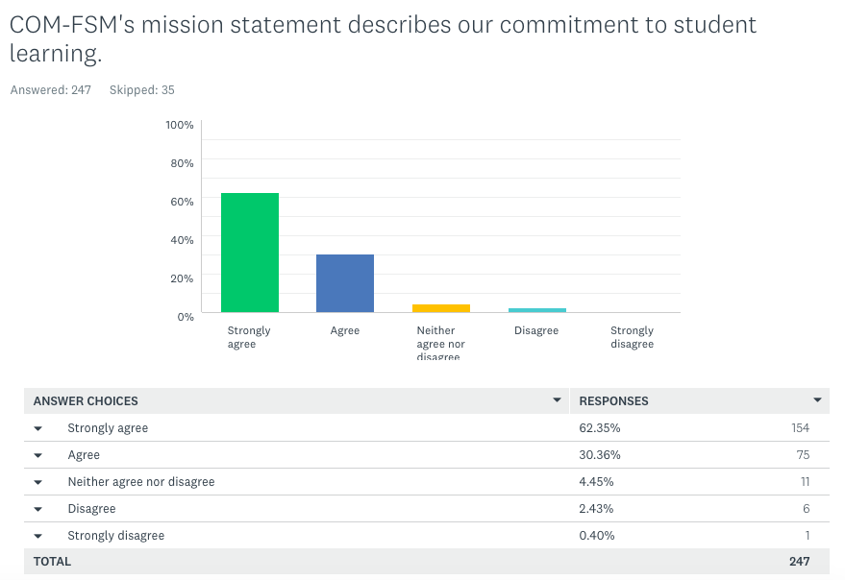

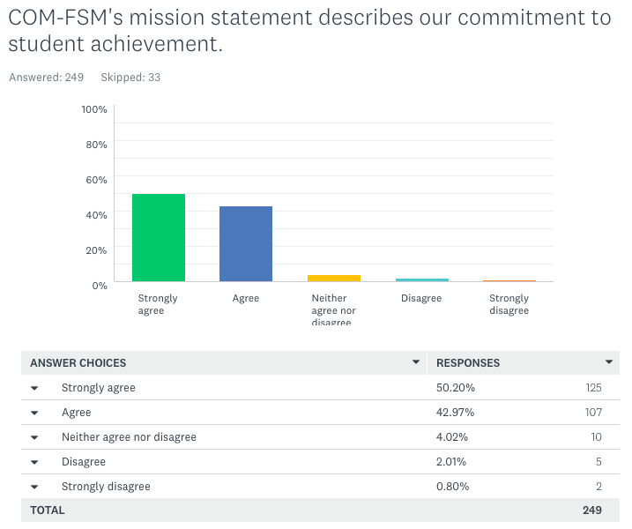

3.2.2. Values review

The College of Micronesia-FSM Core Values and Principles of Best Practices are presented in the Strategic Plan 2018-2023.

We value the higher education community in which we work, and those diverse island communities we serve. As members of these communities, we strive to embody these core values and to demonstrate them through the following best practices.

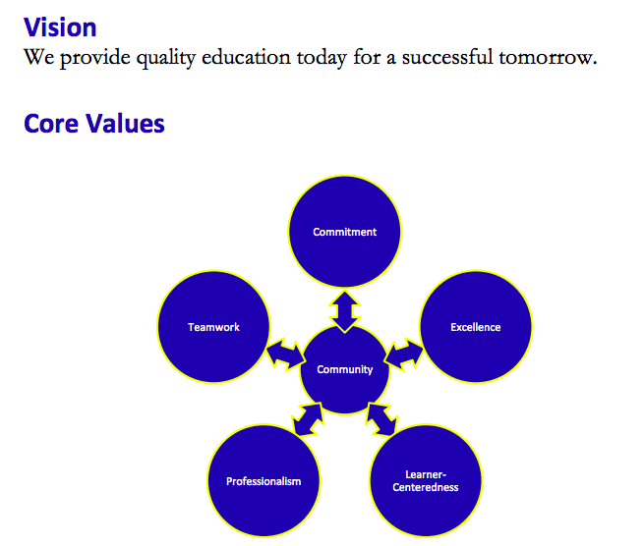

Members of the college community were asked “To what extent do you agree that these values are shown through the actions of COM-FSM?” 247 people responded.

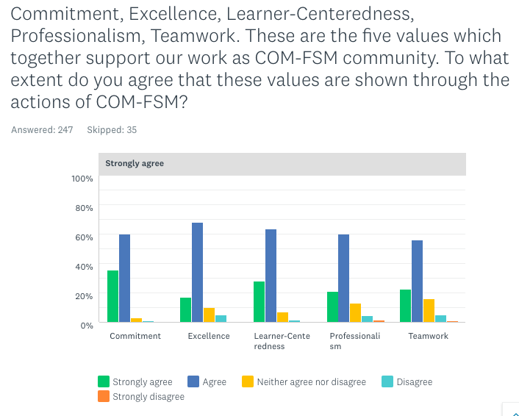

While it is clear that the majority of respondents strongly agree or agree (on average, 86% over the five core values), the value of Excellence necessitates consideration of those who do not agree:

Figure 12: Percentage of College Members who Do NOT Agree that Values are Shown Through College Actions

Open comments to the above question included:
- I strongly agree that these are what we do with the college
- Honesty to oneself is essential to achieving greatness and beyond. Unless one is willing to consider his limitation and admit his needs of commitment, excellence, professionalism and teamwork, he won’t be able to develop beyond his own standard.
- Personally I do witness lack of professionalism among the staff
- Need more cooperation between campuses
- I think there ought to be Creativity and Flexibility added
- The college can be more professional and excellent if the college administration can accept input from college community and stakeholders. There is insufficient focus on student learning and training of faculty and staff.
- Relationships between national campus and state campuses is poor
- In my observation, the college is operating in small units instead of a whole. Each department perceive their roles as a unit instead of embracing and operating for the success of the college as a whole.
- The college needs to put more attention on employees, by acknowledging their areas of need. Many times, employees feel that their needs are not heard or felt by the college. At least internally, the college should be staff-centered.
- So far COM-FSM is doing well and working hard for students’ success
- Some faculty strive for excellence, others just doing their job.
- Employees need to be reminded of these core values, and hospitable towards one another. Interpersonal skills are very important.
- There is always room for improvement

The data presented suggest that COM-FSM must prioritize teamwork and professionalism to better embody its core values.

3.3. External Community Stakeholder Mini-Summits 2020: Are We Living Up To Our Mission?

A mini-summit for each of the four States was held for community members online to review the college mission statement, the extent to which we are achieving it, and consider recommendations to improve.

State | Date & Time | Participants | Including…
Yap | 10/27/20  2pm - 3:30pm | 18 | - Senator, Yap State Legislature Member of Resources, Education Dev. Committee  - Director, Resources & Development  - Department Of Education  - Special Education Coordinator  - Health Services  - Principal, Yap High School  - Yap Cooperative Association  and others
Chuuk | 10/28/20  2pm – 3:30pm | 8 | - Chief Justice, Chuuk State Supreme Court  - Representative, Chuuk State Legislature House of Representatives  - Chief of Public Health  - Principal, Saramen Chuuk Academy  - Director, Small Business Development Center
Kosrae | 10/29/20  2pm – 3pm | 8 | - Kosrae State Scholarship Administration  - Division of Agriculture & Land Management  - Department Of Education
Pohnpei | 11/05/20  3pm – 4:30pm | 4 | - Congress  - FSM Development Bank
Table 16: Online State Mini-Summits Dates & Participants
During the summits, participants reviewed 24 mission fulfillment indicators.
Of these, the data presented that 17 are met (green), 4 are minimally achieved (yellow), and 3 are not achieved (red).

The following indicators are minimally achieved (yellow):
- Graduate Employment Rates: % of students that completed a CTE program and are employed in related field.
- Fall-to-spring persistence rate
- Fall-to-fall persistence rate
- Institution-wide Credit Grades % Completed

These 3 indicators are not achieved:
- Academic challenge benchmark
- Student faculty interaction
- Transfer rate

The following recommendations were made to the Board of Regents and to COM-FSM administration. In addition to being presented here, they will be included in the mid-term report evaluating progress in our Strategic Plan 2018-2023. All States agreed upon the value of sustaining this open dialogue and have scheduled follow-up events in January 2021.

Yap
Recommendation 1
The college should integrate internships and on-the-job trainings in programs to better equip students with employability skills, and align its programs with each State’s priority fields or each State’s manpower plans.
Recommendation 2
Develop vocational and trade programs within Yap state, to address the manpower development needs for the state - to train locals to replace the many foreign workers in many specialized trade areas.

Chuuk
Improve access to diverse Chuukese population to address the low representation of Chuukese students in COM-FSM (20%) when compared to Chuukese population of FSM (47%)

Kosrae and Pohnpei sessions did not make specific recommendations but rather, chose to continue dialogue with broader participation.

Recommendations for Consideration

3.3.1. Mission Statement

No recommendations for changes are made to the existing mission statement.

Mission Statement: The College of Micronesia-FSM is a learner-centered institution of higher education that is committed to the success of the Federated States of Micronesia by providing academic, career and technical educational programs characterized by continuous improvement and best practices.

3.3.2. Mission Fulfillment Indicators

There is significant overlap between mission fulfillment indicators, Institution-Set-Standards, and the Strategic Plan 2018-2023 measures of success.

Recommendation 1: Ensure complete alignment between these measures.

Recommendation 2: Conduct a broad-based participatory evidence-based review of existing measures (mission fulfillment indicators, Institution-Set Standards, and Strategic Plan 2018-2023 measures of success) for their suitability and currency in the distance learning environment and realities of COVID-19.

Recommendation 3: OIE and OIAEA to collaborate to create a comprehensive tracking system for understanding transfer rates to 4-year colleges/universities.

3.3.3. Values

Recommendation 4: Prioritize teamwork and professionalism to better embody COM-FSM core values.

Reference: https://www.ccsse.org/aboutccsse/aboutfaqs.cfm
IPEDS survey components - https://nces.ed.gov/ipeds/use-the-data/survey-components/9/graduation-rates
Total Operating Expenses References 2016 - http://www.comfsm.fm/busOffice/reports/2016/COM-FSM_fs16%20[Final%20June%2029%202017]-1.pdf 2017 - http://www.comfsm.fm/busOffice/reports/2017/COM-FSM_fs17[Final-June-4-2018].pdf 2018 - http://www.comfsm.fm/busOffice/reports/2018/COM-FSM_fs18[Final-Jun-28-2019].pdf 2019 - http://www.comfsm.fm/busOffice/reports/2019/COM-FSM_FS19%20[Final%20Nov%2024%202020].pdf

