COM-FSM Chuuk Campus September 2021 All Campus Meeting
DATE: 9/1/2021 | TIME:12:00pm |  | LOCATION: Student Center
Attendance (In Numbers):

Employees: 36 Students: 124
Agenda/Major Topics of Discussion
- Call to order
- Moment of silence prayer
- Reciting of the College’s Mission Statement
- Welcoming Remarks and Departments Introduction and Reports
- Closing Prayer
VI Meeting Adjournment
Discussion on Agenda/Major Topics of Discussion
- Call to order by: MC Wilson Bisalen
- Prayer by: Reverend Atkin Buliche
- Reading of the College Mission Statement
-The College of Micronesia –FSM is a learner center institution of higher education that is
Committed to the success of the Federated States of Micronesia by providing academic and career and technical educational programs characterized by continuous improvement and best practices.

IV: Department Reports:

- Welcoming Remarks and Department Reports by Campus Dean and Administration Department:

Dean Kind Kanto (Administration Div.) Delivered the Welcoming Remarks by:
- Welcoming students to COM-FSM Chuuk Campus
- Elucidate the reason for hold off All Campus Meeting for a while.
(Due to pandemic condition)
- Task Force allowed the college to start classes (face-to-face & on-line) based on the approved SOP (Standard Operating Procedure). We must comply with our SOP.
- Social Distancing
- Face Masks
- Checking of temperature
- Students should cooperate with staff and faculty advices.
- Wilson continued with the introduction of Administration staff.

- Instructional Division’s Introduction of Faculty and Reminders:

- IC, Genevy Samuel introduced her Faculty and her staff
- She also made a Reminder that September 13th, 2021 is the Early Warning Deficiency Reports due.
- She also explained the purpose of Early Deficiency Report
- She also informed the students that October 4th-5th, 2021 is the Mid Term Deficiency and the due dates from Instructors for Mid Term Deficiency Listing is on October 8th, 2021.

- Student Services Staff Introductions, including New Hires and Reports:

- SSC, Kestery Enlet introduced the Student Services Division staffs including new hires of the Financial Aid Assistant, Tutors, and a new security.
- Reminders for students ages 18 and older to get their COVID-19 vaccine shots as it will eventually become a requirement for students to get their vaccine shots.
- She also reminded students to pick up and fill out their FAFSAs as soon as possible and not to wait for the deadline.
- She ended by calling out to the students that have incomplete FAFSA to visit our Financial Aid assistant at the Admissions Office.
- Wilson also continued by reminding students to pick up and submit their Work Study Pre Applications no later than tomorrow, September 2nd, 2021 at 5:00pm to our Admissions Office. He repeated the eligibility criterias as, must have 2.0 GPA, be on Degree Program carrying a 2.0 GPA or above and must not be on any Academic or Financial Aid troubles.

- CRE Presentations/Reports:

- CRE Acting Coordinator Mr. Kalvin Assito introduced his program and staffs as well as new hires through a power point presentation.
- Dr. Lolita finished CRE’s time by also presenting the promotion of flower (Dora-scientific name) and gave out food samples. The benefits of this type of flower are:
- Helps cure boil
- Helps reduce blood pressure
- Helps sore throat

V: Closing Prayer: Reverend Ada Anep

VI: Meeting Adjournment at 1:00pm.

Next meeting:TBD
Hand-Outs/documents referenced: Attached All Campus Meeting Pictures
Prepared by: Tandy Marar |  | Date distributed: September 1st, 2021
Summary/ Recommendation/Action steps/Motion with timeline/Responsible

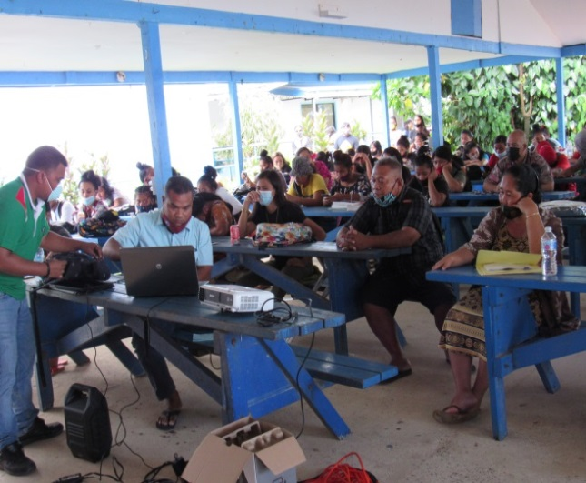
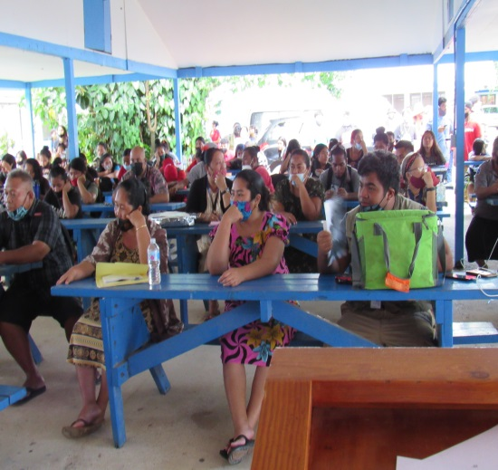
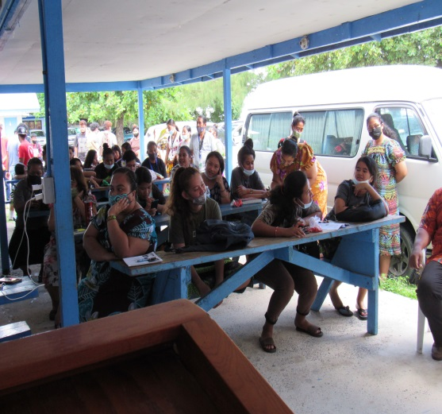
All Campus Meeting Pictures
